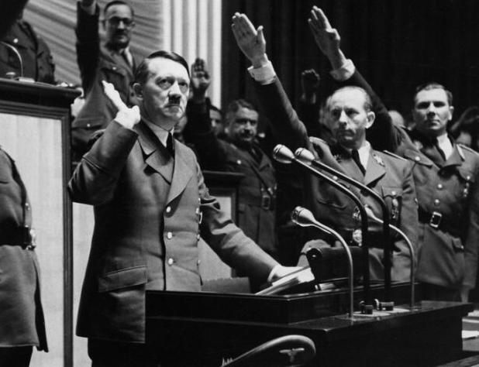
_______________________________Night of the Long Knives____________________________
What is Hitler’s dilemma by the end of 1933?

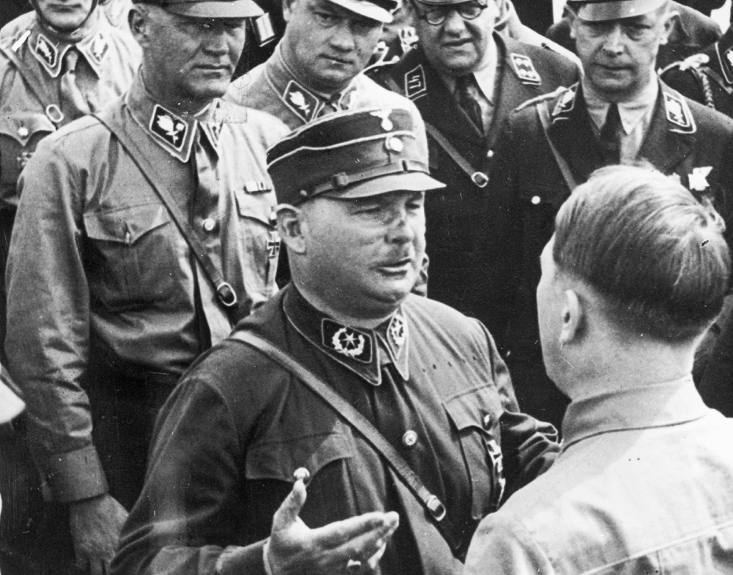
What mistake does Rohm make?

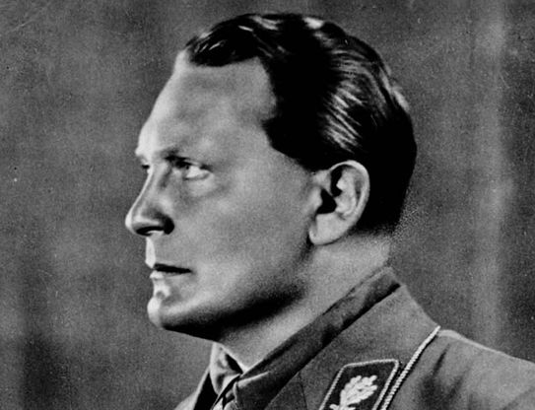
Who is Rohm's enemy, and what does he do?

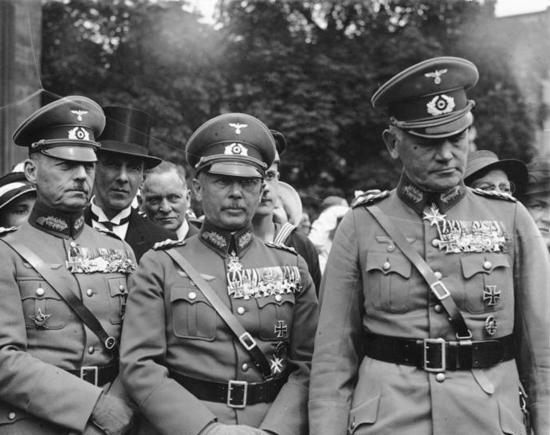
Why is Rohm so bitter?

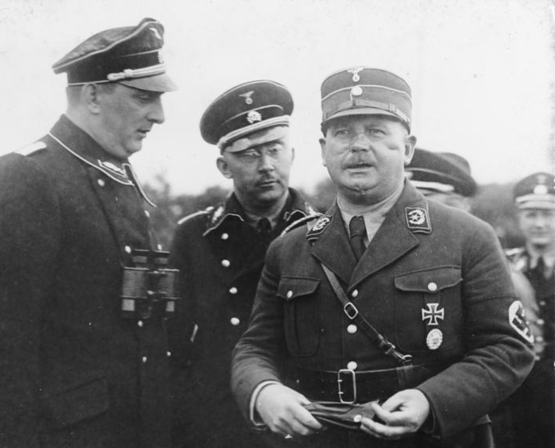
What is Himmler’s issue with Rohm and what does he do?

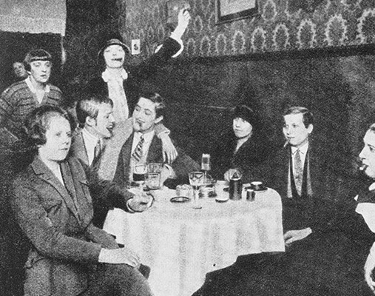
Why is Rohm’s personal life an issue?

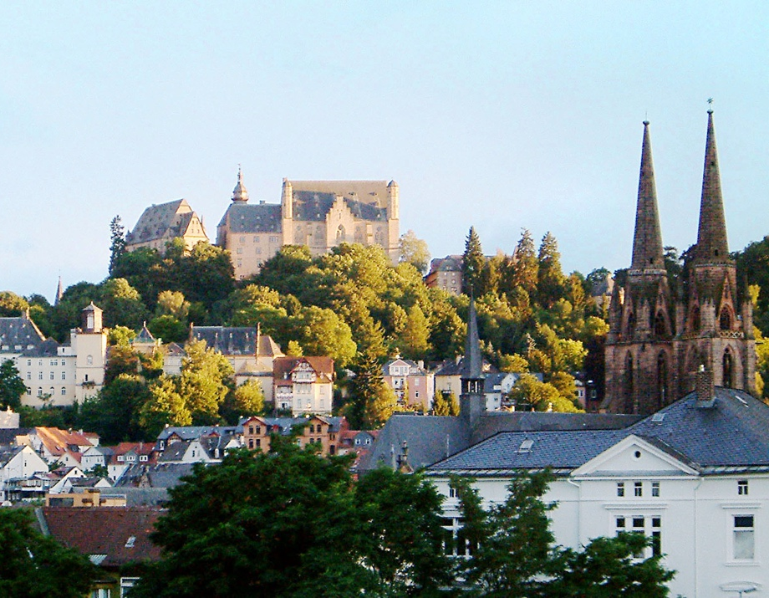
What was the significance of Papen’s Maarburg Speech?

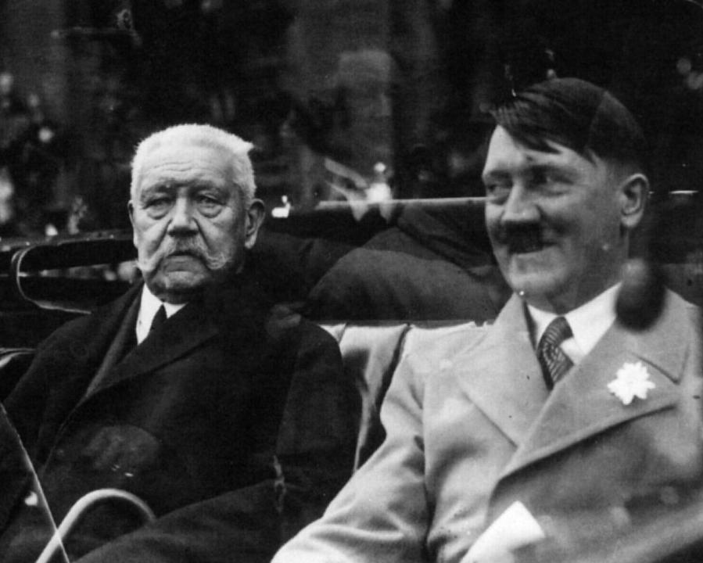
How does Hitler give himself temporary respite?

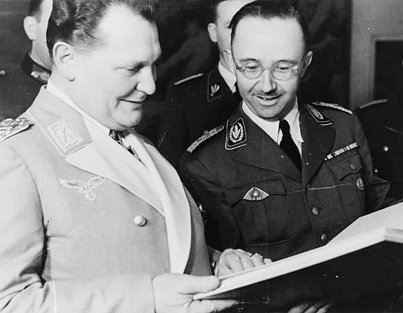
How is Hitler duped by Goring and Himmler?

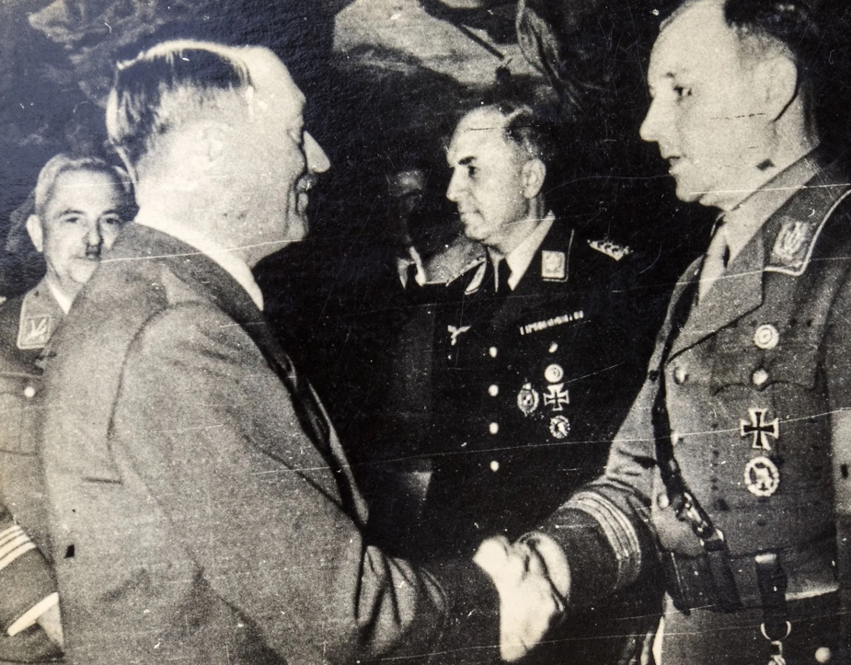
Why does Hitler finally decide to act?

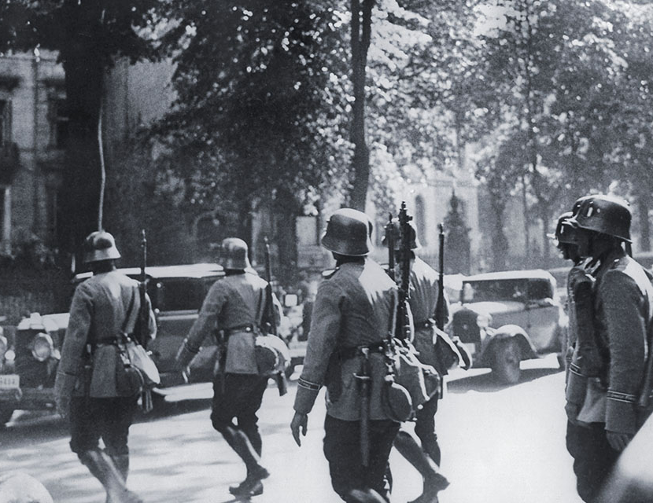
Describe the events which took place during the Night of the Long Knives?

What was the importance of the Night of the Long Knives?

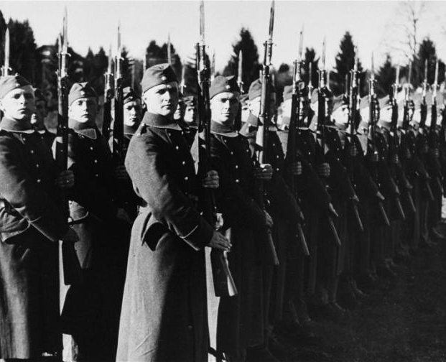

Points not on the video:
Causes
- By the middle of 1933, SA membership had swelled from 500,000 to 2.5 million.
- As Hindenburg was dying of lung cancer, Papen told Hitler that the constitution should not allow him to be chancellor and president and that they should restore the monarchy. Hindenburg seemingly approved of this plan. Bloomberg warned Hitler that Papen was planning on replacing Hindenburg.
- Unemployment remained high at 4 million (albeit down from 6 million in six months as Hitler implemented Schliecher’s work creation program). A wage and price freeze had shrunk living standards still further. In rural areas, the process of ‘coordination’ had caused deep conflicts, especially in Catholic regions, as the Nazis attempted to suppress Catholic social groups and youth organisations, both of which remained popular. Many SA members were contumacious towards the squeamish weak leadership unwilling to dismantle the old bourgeois order. With few enemies left to harass, the SA became even more unruly frequently turning on each other. Desperate to impose discipline Rohm proposed them replacing the army.
- Hitler had been humiliated on his first overseas visit to Italy. He had been thoroughly upstaged by the impeccably dressed Mussolini, subjected to an embarrassing game of golf, and then the Duce left the final banquet early.
- After a Social Democrat killed two SA members defending himself in Kopenick, Berlin, there was a wave of recriminations, with 500 arrested and 91 killed. The SA were out of control. Goring responded by removing SA members as temporary police.
- The new head of the Reichsbank, Hjalmar Schacht, warned that the constant disorder on the streets was frightening away any prospect of foreign investment.
- The treatment of prisoners in SA facilities was so horrific that even Goring ordered them shut down.
- Exacerbating this state of affairs was the absence of a real organisational table or a clear chain of command, even in critical areas such as the economy and police. At the top, the Third Reich resembled a medieval court, with loyal vassals vying for Hitler’s favour while operating with surprising independence. Party and state agencies competed to interpret and implement the Führer’s will. Hitler rarely intervened and never put his orders in writing; they were verbal, notoriously vague, and often contradictory. At every level of the state and party apparatus, officials sought to “ work toward the Führer” but essentially acted independently in organised chaos. In the general scramble for power and influence, personal jealousies were rampant, conflicts of interest were widespread, and offices lacking clear lines of responsibility proliferated. The result was a highly inefficient polyarchy with multiple centres of power-driven by a crude “institutional Darwinism,” where the strongest, most forceful, and most persistent individuals prevailed.
- The chaos allowed three different police organisations to develop. Himmler’s SS, Gorings Gestapo, and Rohm’s SA. Not all of them could coexist. At the same time, Rohm was complaining he had been betrayed, Goring willingly handed over control of the Gestapo to Himmler.
Consequences
- The official death toll was 85, although it is likely around 100. Many were mistakingly killed, notably the music critic Wilhelm Shmid who was confused for Strassers associate, Ludwig Schmitt. Twelve were members of the Reichstag. 1,100 were arrested.
- Victor Lutze, a minor official with no political ambitions, was put in charge. Lutze organised the downsizing of the SA, disbanding scores of units and redeploying talented men to the SS. By 1938, SA numbers had dropped to 1.2 million members—one-quarter of the numbers from four years before.
- On July 2, Hindenburg sent Hitler a telegram commending him for “your own determined action and your brave personal intervention. You have rescued the German Volk from a serious threat. For this, may I extend to you my deeply felt gratitude and my sincere appreciation?” A similar telegram went to Göring.
- The army breathed a sigh of relief. General Blomberg expressed his gratitude and assured Hitler of the complete devotion of the army. He congratulated Hitler on his ‘soldierly decision’ to deal with ‘traitors and murderers’.
- Alongside Rohm, Strasser and Schleicher, other prominent figures killed included Catholic politician Erich Klausener who had been strongly critical of Nazi violence, and Gustav Ritter von Kahr, who refused to back Hitler in Munich in 1923. Schliecher’s wife was accidentally killed. General Ferdinand von Bredow, a friend of Schliecher’s was killed. Those involved in Hitler’s imprisonment in 1923 or previous critics were killed. Even the landlord of the beer hall in Munich, which Rohm and his gay friends frequented, was executed. The leader of Jewish Veterans League was murdered. Strangely, some of those imprisoned with Hitler in 1924 were eliminated.
- There was little sympathy for Rohm within Germany or in the overseas press. He was regarded as a thug and a bully with his sexuality also a contributing factor.
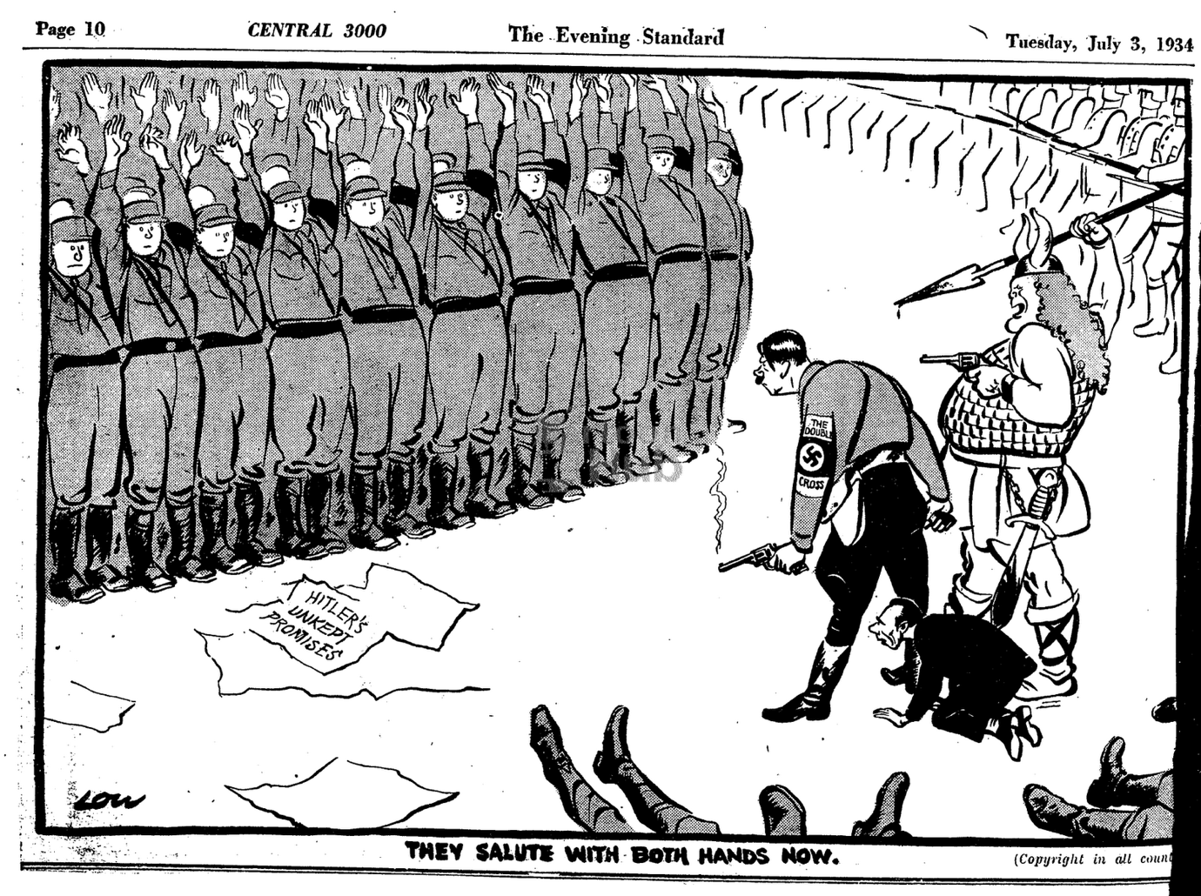
What is the message of this cartoon?

