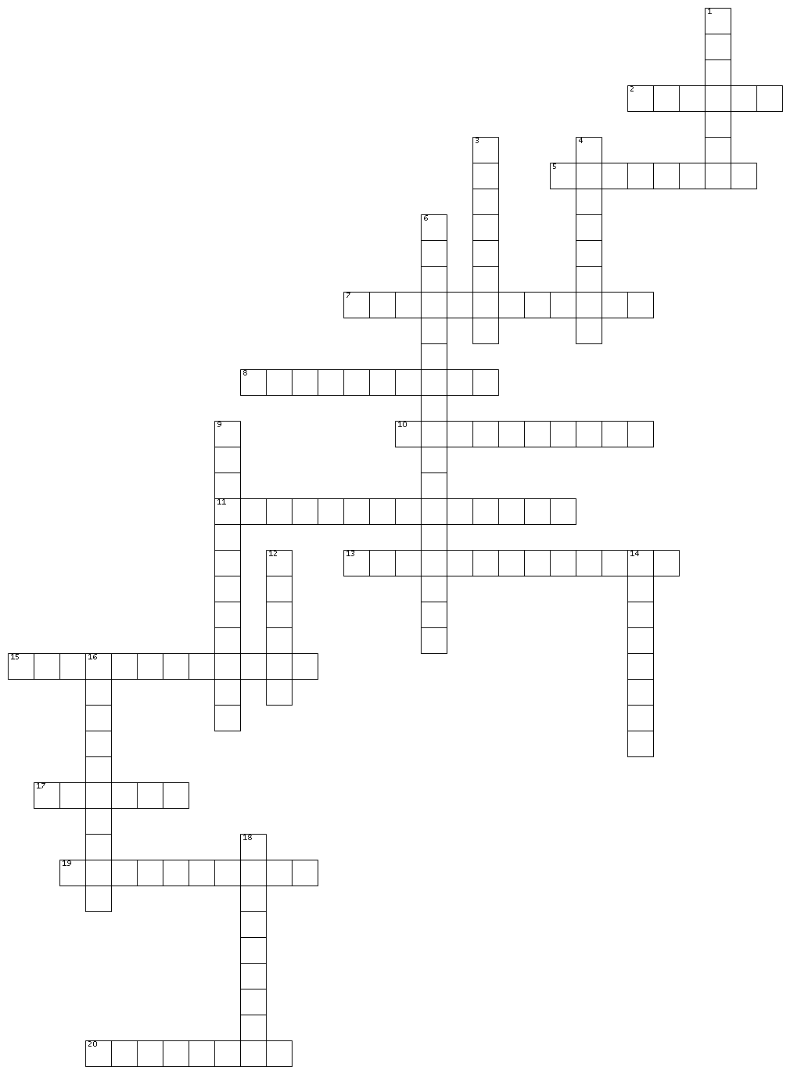
________________________________Long-Term Causes: Vocabulary_________________________________

ACROSS
2. A member of an Eastern European ethnic group
5. Taking away or lacking something
7. Freedom from another control
8. A brief attack
10. Not fitting together
11. An organisation that promotes notions of their nation's empire
13. Restoration of political unit
15. Completely destroying
17. Feeling the same emotion
19. Regaining pride or esteem
20. Ended positively
DOWN
1. To seek a reaction
3. Feel bitterness
4. Being materialistic and self indulgent
6. A foreign area where a country claims predominant control.
9. Advocating an aggressive foreign policy
12. Empty
14. Being fixated on something
16. Permanently discontented
18. Being very different

