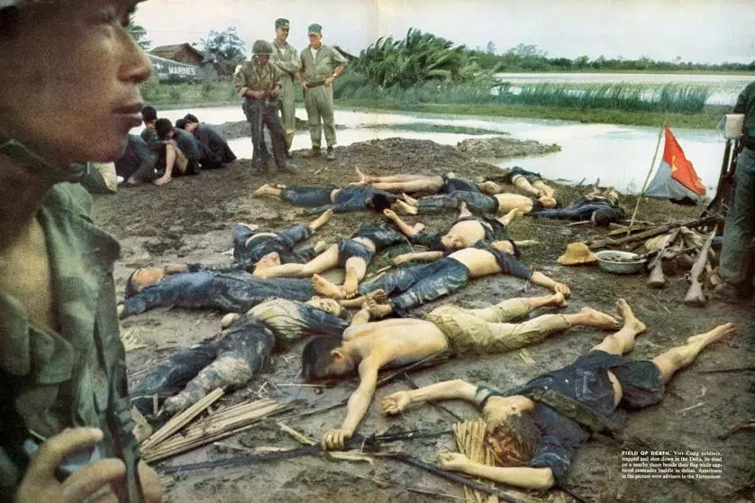
___________________________________________________________________Why was America in Vietnam?_______________________________________________________________________
KENNEDY

Flaws of Diem

Creation of the Viet Cong

Failure of Strategic Hamlets

ARVN and Ap Bac
JOHNSON

Assassination of Diem

Gulf of Tonkin
EISENHOWER

Dien Ben Phu

Domino Theory

Geneva Accords

Military Assistance Advisory Group

Nation Building
Websites to Use:

- GCSE Bitesize - About Education - History learning Site

- History Net - History Channel - BBC News

- Spark Notes -Oxford OxCon School -GCSEHistory.org

