Events in Cuba Leading to the Cuban Missile Crisis
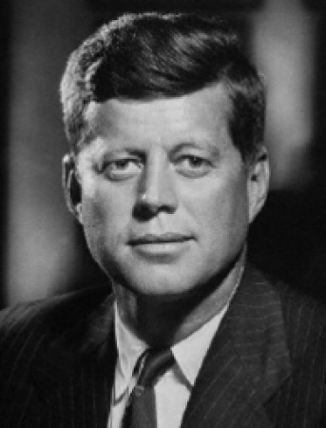
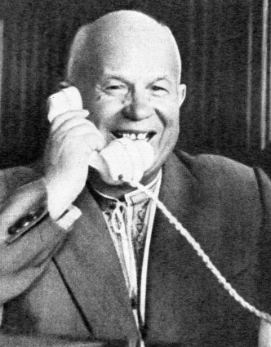
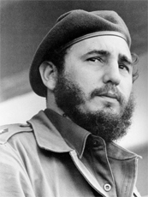
 | Pro- Castro | Pro-USA | Pro Soviet Union
The Revolution

CIA and the Bay of Pigs

Defending Cuba

Reaction to the Missiles

