_____________________The Cold War Moves to Asia: 1949-1953_________________________

Thermonuclear Weapons

In early September 1949, an American weather plane detected radioactivity in the atmosphere above Siberia. Truman had felt it would be a few more years before they developed the bomb, but yet still knew that US dominance would not be indefinite

Truman now authorised the development of the Thermonuclear bomb, fearing that Soviet development would give them the ability to enforce their will on America. Eventually, the American H Bomb obliterated Entiweok Atoll in 1952, releasing 500 times the power of Hiroshima.

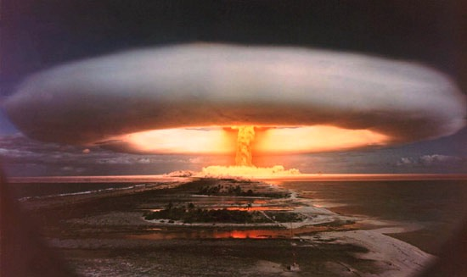
Possible Global Consequences?

China Goes Communist

Throughout the Second World War, the USSR had been happy to allow US leadership in China. Mao realised he would have to negotiate with the Guomindang so long as the Soviet-US alliance continued. Chiang Kai Shek realised he could not completely destroy the CCP lest the USSR intervened.

At the point where Chiang should have cemented his control, he made a bad misjudgment. Believing Mao could not gain power, Stalin turned Manchuria over to Chiang in exchange for future economic concessions. The Chinese Communists objected and occupied Manchuria anyway, sparking clashes with the Guomindang. The US-backed Chiang, and emboldened, he dragged his feet on implementing his agreement with the Soviets. Frustrated and with commitments elsewhere, the USSR withdrew its forces in March 1946 to drive Chiang back to the negotiating table. Instead, they had turned the advantage over to the Communists.

The tensions between the USA and USSR meant that a full-scale civil war began in June 1946. The 110,000 US troops stationed in China were involved in skirmishes with CCP soldiers, and Soviet soldiers came south into Manchuria to protect CCP forces there. Though the US and the USSR would eventually take a passive role in the Chinese Civil War, creating a secure base in Manchuria was hugely important to the CCP’s success. The Communist commander Lin Biao was a talented commander, and he absorbed the Guomindang offensives in 1946-1947 before picking off his enemies’ divided forces in 1948.

While Chiang got into trouble on the battlefield, he also began weakening his position in the cities and other areas controlled by his government. Chiang was a man in a hurry. He wanted too much too fast. First and foremost, he wanted to build a strong central government that could guide and fund an economic and social revival for China. Instead, his precipitous actions hurried the downfall of his regime. By mid-1948, the peasantry deserted him because they resented seeing their sons press-ganged into the army for an increasingly hopeless cause. The landowners gave up on the Guomindang because Chiang seemed intent on bringing his own men into their provinces to rule them. The bourgeoisie turned against the government because it drove them into penury through inflation and corruption. The working class in the cities—among whom the Guomindang had some support and the CCP none—was the last group to run away from the regime, but in 1949, when the CCP armies overran all of China, few workers came forward to die for the Nationalists.

Stalin had been less than thrilled with the emergence of a vast Communist state on its southern border, especially one with which he had no formal control. The Soviet Union had not recovered from the Second World War; it had no desire to support Communism in a country as vast and poor as China.

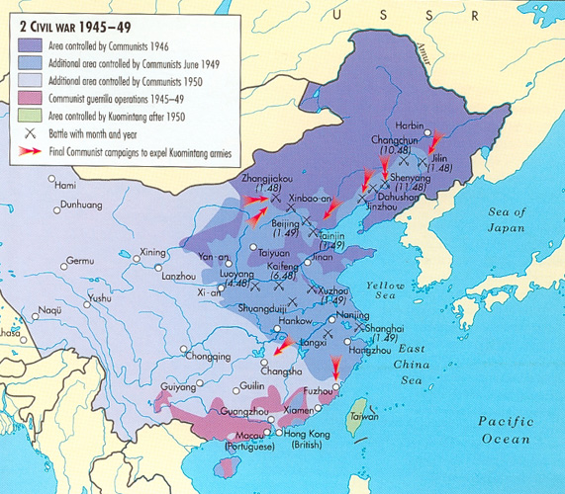

In America, the fall of China was even less unexpected than the Soviet atomic bomb. The nationalist government had few natural supporters, was corrupt and had exhausted itself fighting the Japanese from 1931-1945. Mao had promised land reform, and it had become clear to all advisors on China that, eventually, the nationalist government would fall. By 1948, the US realised that without direct military intervention, Chiang would lose. George Marshall told the Chinese ambassador, Wellington Koo, that US aid would cease as 40% of it was ending up in Communist hands. Truman was not particularly concerned by the change in China. “We picked a bad horse”, he merely said, having previously described Chiang Kai Shek’s government as the world’s rottenest. Most in the US government believed that China was too poor and fractious to add to the strength of the Soviet Union.

Secretary of State Dean Acheson speculated that as soon as events settled, they could probe the nature of Soviet ties to China and offer diplomatic recognition. The critical problem was the closing of a significant Japanese market, but Chinese Communism did not threaten the USA in any way. Initially, the US offered little support to Chiang in Taiwan, hoping that Mao would become another Tito.

The “China Lobby” was prominent, comprising business owners, journalists, and right-wing lawmakers. Time Magazine was particularly critical of Truman for ‘losing’ China and blamed the State Department's incompetence rather than Chiang Kai Shek. Republicans had not held meaningful power for 16 years. They took this opportunity to accuse Truman of being soft on Communism. A little-known senator from Wisconsin called Joseph McCarthy was beginning to make a name for himself by accusing the State Department of being infested with Communists and Hollywood producing Communist propaganda. These attacks resulted in HUAC, the execution of the Rosenbergs, and political repression unseen in American history.

Mao overestimated the amount of support that America had provided for Chiang; he failed to grasp that the support the US had provided was the minimum amount required to appease the ‘China Lobby’ and stop it from becoming a domestic issue rather than a genuine attempt to keep the Communists out of power.

Stalin did not trust the “class-basis” of the Chinese Communists. They were peasants, he concluded, rather than workers. Theirs was a “national” rather than a socialist revolution, and they should govern in alliance with the national bourgeoisie, at least to begin with. Deeper down, Stalin distrusted the CCP for coming to power independently rather than relying on the Soviet Red Army. As he grew older, he increasingly suspected anything and anyone he could not directly control. Mao had been humiliated by his journey to Moscow, where he suffered a number of indignities, and Stalin did not even greet him at the train station. He eventually got a friendship treaty but had to accept Soviet guidance and mineral concessions for a $300 million loan. Mao got his alliance but was not happy about being treated as a curiosity rather than as the great master’s foremost disciple, which he so much wanted to be. These slights would seriously affect Sino-Soviet relations in the next 20 years.
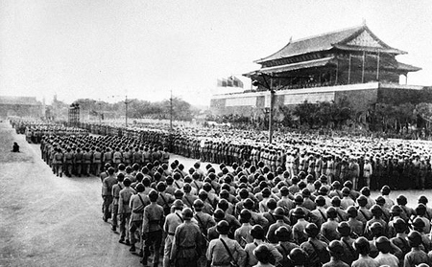
How far was China’s revolution a Cold War crisis for the USA?

NSC – 68

In response to the Soviet Atomic bomb and the CCP victory, which were causing political headaches, Truman ordered a review of Cold War policy. The resulting document created by Paul Nitze recommended a vast increase in the scale of American commitments. The Truman Doctrine of 1947 was not specific but aimed at stopping the Soviets from undermining democratically elected governments. The USA had provided some assistance to governments opposing left-wing or communist movements in the third world, but there was little prospect of direct intervention. Nitze argued that now Stalin had the bomb, he would be emboldened to spread Communism to every corner of the world. America would now have to oppose not the Soviet Union but Communism and thus undertake a massive expansion of its peacetime army.

Leon Keyserling realised that the American public would not support such a limitless crusade if they were required to pay higher taxes. Thus, he advocated deficit spending, setting the US on an unsustainable path of expenditure, which has only recently reached a crisis point.
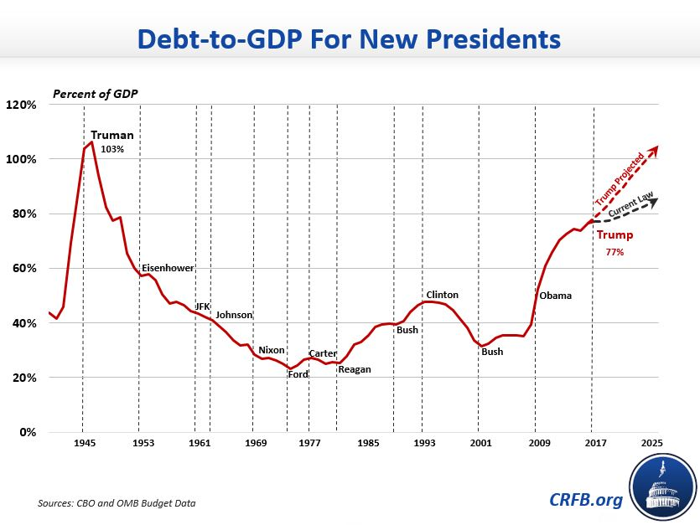

What problems could NSC-68 cause the USA?
Korea - Causes

American/South Korean Actions | Soviet and North Korean Actions
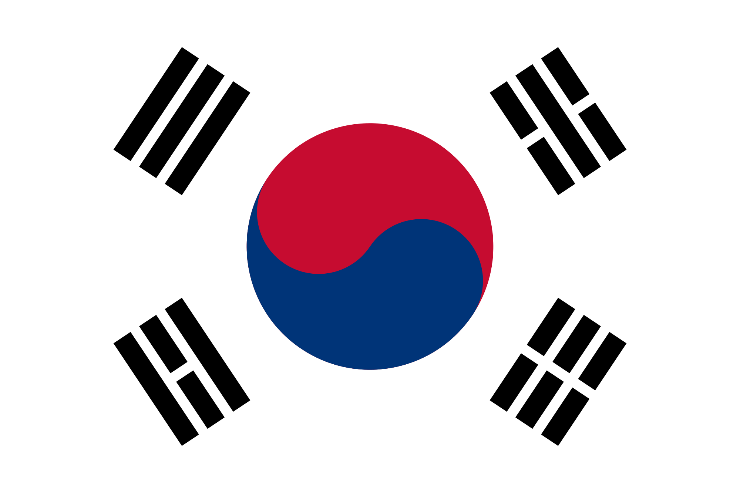  1.  2.  3.  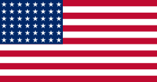  4.  5. | 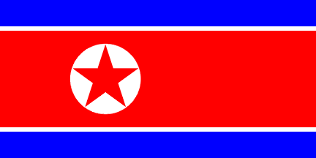  1.  2.  3.  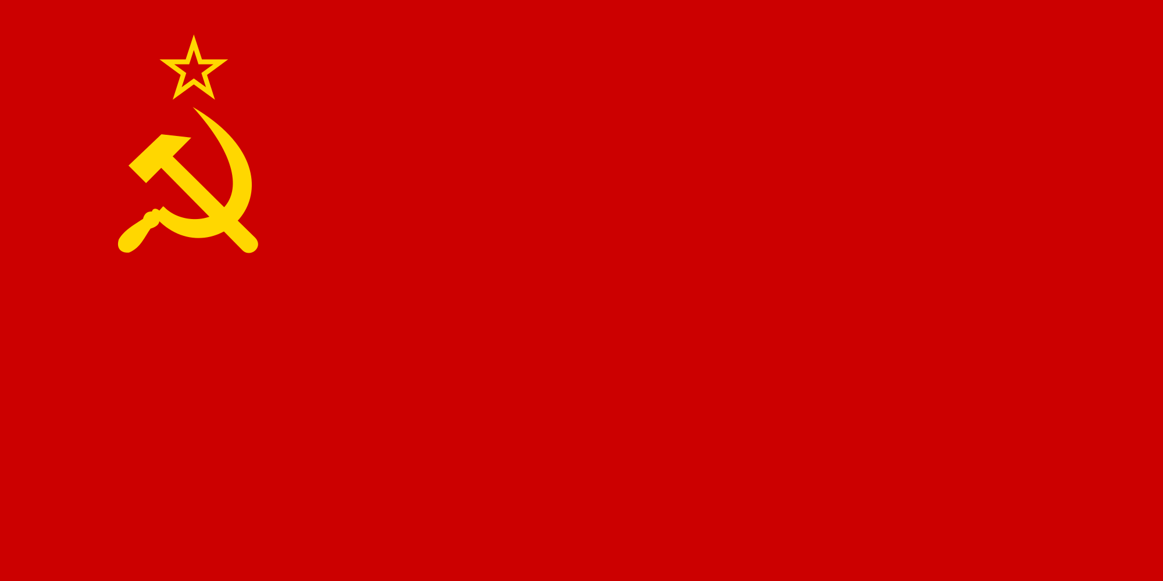  4.  5.

After the lack of international revolutionary success in the interwar years and the searing experience of World War II, Stalin did not want to risk unnecessary confrontations with the United States and Britain over peripheral areas. The nationalist Communist movements were more challenging to control and weak post-colonial governments could drain the limited Soviet finances. Still, countering Communism in Asia could draw Western attention away from Eastern Europe whilst widening division within those countries. Based on his reading of Soviet (and Russian) history, Stalin’s view was that there was only one Asian country that mattered to Moscow in the short run. That country was Japan. And it was there, ironically, that the Soviets seemed to have the slightest prospect for direct influence when the war ended.

Korea had been hastily divided at the 38th Parallel in 1945. The solution didn’t suit anyone and was only conceived as a temporary measure. Most of the industry was located in the North, but as an agricultural country, the majority of the population lived in the South.

The US had put Sigmund Rhee, who had lived in the US for the last 30 years, in charge of South Korea. The US disliked Rhee, but there was no alternative. He was so virulently anti-communist it left no prospect of unification of the two Koreas. The US was not particularly popular in South Korea; there were no land reforms, rice was distributed poorly, and it could not generate enough electricity or cope with refugees from the North. It relied on right-wing elements to keep order, many of whom had collaborated with the Japanese.

North Korea was under the control of Kim Il Sung, a Communist guerilla who had served with the Chinese Communists in the Second World War before crossing the border to serve with the Soviet Army. Stalin had selected him due to his youth, which he hoped would make him more amenable to following orders, alongside his distance from other Korean communists, few of whom survived the purges and expulsions of the 1920s and 1930s. Kim was initially popular, but the brutal nature of his reign saw an increasing number flee to the South. Neither side could guarantee victory in a unified election, with 16 million in the South compared to 9 million in the North, but the North had a much larger army.

Up to the end of 1947, the Soviets and Americans toyed with proposals for Korean self-governance under an international trusteeship as a way to avoid a conflict between the two powers over control of the peninsula. Likely, Stalin did not entirely give up on such an approach until the end of 1948. What cemented the division of Korea was the stubborn unwillingness of Rhee and Kim to agree to any plan that did not help reunify Korea under their own rule, along with the intensification of the Cold War elsewhere in the late 1940s.

Rhee declared the Republic of Korea (ROK) in Seoul after the May 1948 elections. Kim Il-sung followed up by announcing a new state from his northern capital, Pyongyang, in September. Making it a “People’s Republic” was not enough for Kim; he named it the Democratic People’s Republic of Korea (DPRK), in line with the slogans used at the time. The new governments got the blessing of their respective Superpower sponsors. Ironically, Stalin and Truman seemed at the time to have believed that the creation of separate states made war less likely. In any case, both Soviet and US troops were withdrawn from the Korean peninsula soon after the new regimes were set up.

Syngman Rhee undertook forays into North Korea to unify the peninsula, and circumstantial evidence suggests he had US approval. There were guerilla incursions from the North into Yosu, Sunchon and Jeju, which claimed around 30,000 lives. The US gave little military support – the status quo suited their interests.

Eventually, Stalin changed his policy and approved Kim’s unification plans. He did so as:
- The success of the Chinese Communists showed that the Americans were reluctant to intervene on the Asian mainland. In addition,
- Stalin was increasingly annoyed by his lack of success against the United States in Europe.
- The balance of forces between North and South was now in favour of the Communists. According to Stalin’s experience with US patterns of action in Europe, this would not always be the case.
- Korea was a perfect test case for the “internationalism” of the new CCP regime in China.
- The Soviet nuclear test.

Still, Stalin gave little support to Kim Il Sung’s planned full-scale invasion (providing enough weapons to arm three divisions), making him gain Mao’s permission and telling him, “If you get kicked in the teeth, I shall not lift a finger.” Here, Stalin was testing Mao, who he knew was against the invasion (Mao favoured consolidating his rule before aiding insurgents in Vietnam). If Mao said yes, he would sign on to an offensive on his borders over which he had little say. And if he said no, he would have proven himself to be less of an international revolutionary leader than Chinese propaganda indicated.

The preparations for an attack on the South began as soon as Stalin had given his go-ahead. Hundreds of Red Army military advisers were still in Korea, and more arrived in May and June. It was mainly the Soviets who drew up the plans for the offensive, and they based it on their highly mobile campaigns against Germany and Japan at the end of the Second World War. Large amounts of mobile artillery and tanks were sent from the USSR, with technical staff to prepare and maintain the weapons.
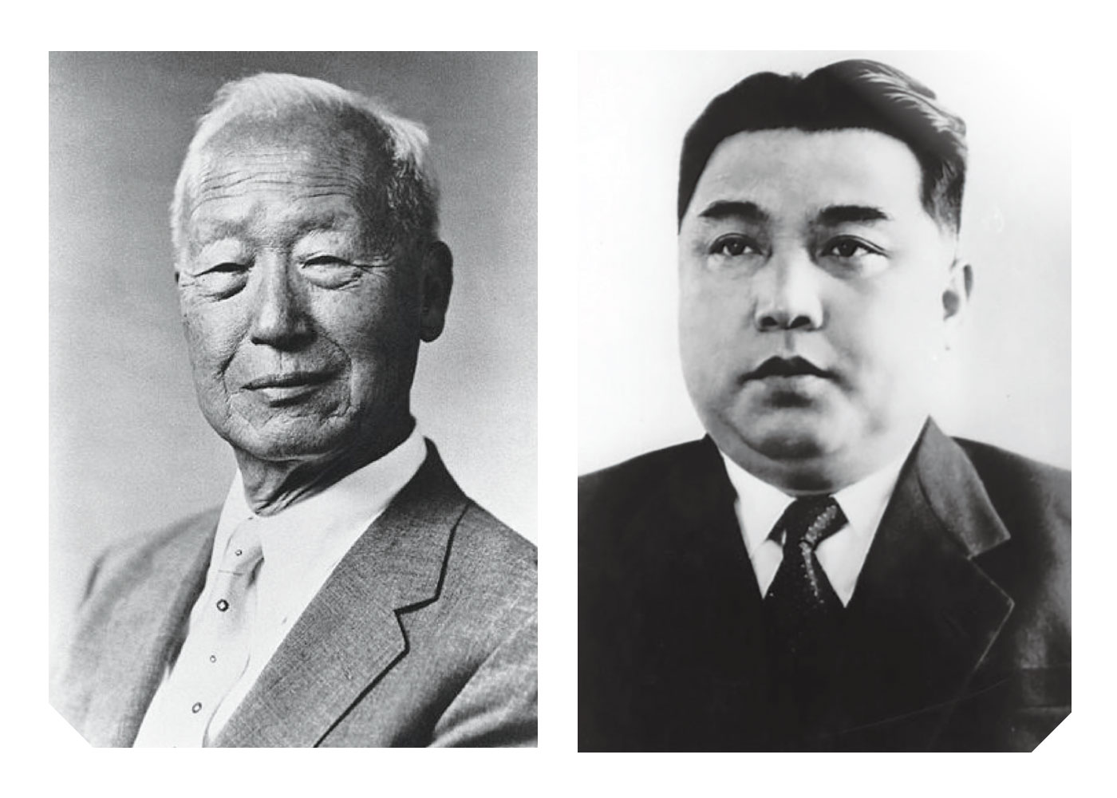
Why did North Korea invade South Korea in June 1950? | Why did the USA become involved in resisting the invasion of South Korea?
1. | 1.
2. | 2.

Korea – War

At dawn on 25 June, the North Koreans attacked on a broad front across the thirty-eighth Parallel. The plan was to capture Seoul and then encircle the South Korean army in the central part of the country. Over the first week, chaos and confusion reigned on the South Korean side. Seoul fell on the third day of the offensive, and Rhee fled toward the South. The South Koreans lost three-quarters of their fighting troops, mainly through defections. The encirclement plan proved unnecessary because resistance was so light, although about twenty thousand of Rhee’s soldiers did manage to flee to the southeastern coast. Both sides committed atrocities as the fighting developed. Rhee’s regime massacred Leftists held in their prisons. The North Koreans executed ROK officials as they advanced.

In Washington, President Truman immediately decided that the war was a case of outright Communist aggression to further reduce US influence in Asia and test the will of the United States and its allies on a global scale. Coming mere weeks after NSC 68, the invasion confirmed suspicions about Stalin and offered Truman a chance to reprove his anti-Communist credentials and shore up Japanese support. He ordered US forces to resist. The President also introduced a resolution at the UN Security Council that condemned the North Korean attack, determined that it was “a breach of the peace,” and ordered an immediate withdrawal. The resolution passed unopposed because the Soviets boycotted the council on account of the US refusal to seat the People’s Republic of China (PRC) there. The following week, the Security Council passed a follow-up resolution, which called for all UN members to “furnish such assistance to the Republic of Korea as may be necessary to repel the armed attack.” It established a unified UN military command in Korea, led by the United States. The UN resolutions were gigantic victories for the Truman Administration. Not only did they give legitimacy to a US offensive in Korea, but they also required other countries to assist in the operation.
What problems did the US military have (video)

Describe the US counterattack at Inchon (video)

In Moscow, Stalin was furious and accused the North Koreans of incompetence and his own military advisers of criminal negligence. But he was still not willing to intervene to help Kim. Instead, he sent a message to Mao on 1 October where Stalin, as often on receiving bad news, claimed to be on vacation and not fully au courant with events. But he had learned that “the situation of our Korean friends is getting desperate.” “I think that if in the current situation, you consider it possible to send troops to assist the Koreans, then you should move at least five-six divisions toward the 38th parallel at once,” the Boss opined. Initially, the Chinese had little interest in involvement in the Korean War, seeing it as a Soviet responsibility. However, the scale and success of the US involvement, an increased US presence in the Taiwan Straits, and helping the French in Vietnam (Indo-China) convinced the CCP leadership that the US was engaging in a strategic expansion directed at China. The crossing of the 38th Parallel and Soviet insistence caused Mao to intervene in October 1950, even though he did not have much support amongst the CCP leadership.

The UN forces had overextended and became overconfident with plans to unite the whole peninsula. On 9 October 1950, Mao sent 300,000 Chinese soldiers across the Yalu River. European countries began to become nervous about the entire operation.

Why were the Chinese initially successful? (video)

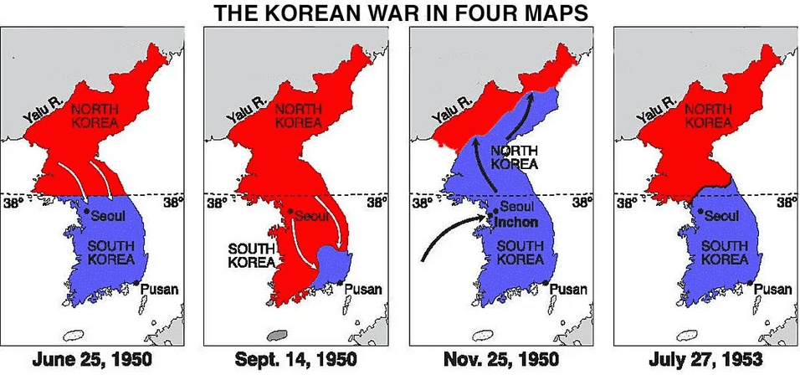

The Firing of Douglas MacArthur
How did the US recover and what divisions arose within the US command? (video)

MacArthur had presidential ambitions and had indicated his interest in the 1948 Republican presidential nomination, although he did not officially declare his candidacy. A poor showing in early primaries prompted him to abort the campaign.

In their first face-to-face meeting on Wake Island in the Pacific in October 1950, MacArthur assured Truman that the UN advance north of the 38th Parallel would not provoke Chinese intervention and that the war would soon be over. MacArthur was wrong on both counts. In late November 1950, Chinese troops launched a significant attack, causing numerous casualties. Chinese troops soon drove MacArthur’s forces back across the 38th Parallel and seemed on the verge of forcing the UN troops out of Korea entirely. MacArthur, suddenly pessimistic, sent repeated messages to Washington claiming that UN forces could not hold out very long and nuclear weapons should be employed against China. At this point, the Truman administration dropped the idea of unifying Korea and sought to maintain the South's anti-communist government. MacArthur, however, would not accept this change in strategy.

MacArthur showed little respect for Truman’s ability to wage war effectively. After China’s attack, MacArthur began to challenge openly the administration’s authority over the waging of the war. He exceeded the authority vested in him by Truman by giving orders without clearing them with Washington. He ordered the Air Force to bomb the Chinese border and to “drive forward with all speed and with full utilisation” of all forces-- actions not authorised by the President. MacArthur explained in communiques to Washington that he intended to secure all of North Korea, arguing that to do less would be a “psychological” disaster for the troops.

MacArthur wanted to blockade the Chinese coast, destroy China’s industry with air power, and employ Taiwanese nationalist forces against the Chinese mainland. Moreover, he sent cables to various news organisations informing them of his views. Truman considered firing MacArthur but held off, hoping to avoid a major political controversy amid a military conflict. Although Truman issued a directive in December 1950 forbidding direct statements to the press by military commanders on issues of strategy, MacArthur kept making public statements.

Truman found himself in a bind. Unwilling to risk all-out war with China, which he believed would draw in the Soviet Union as well, Truman had to take the brunt of public and political criticism for keeping the war in Korea limited. As the President saw it, total war in Korea could mean war with the Soviet Union. But limited war aims left him open to the charge that he was “soft on communism,” despite the successes of the Truman Doctrine and the Marshall Plan in containing Soviet expansion in Europe. In this situation, Truman’s ratings in opinion polls took a nosedive. Truman explained later, “I fired him because he wouldn’t respect the authority of the President. I didn’t fire him because he was a dumb son of a bitch, although he was, but that’s not against the law for generals. If it was, half to three-quarters of them would be in jail.”

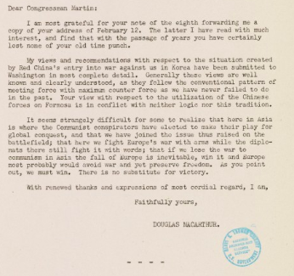
Why might this letter see MacArthur fired when it was read in the house?

Why was Douglas MacArthur Fired?
1. | 2.

End of the War

In mid-March, UN forces retook Seoul for the second time, and their forces established and held a fragile front line very close to the thirty-eighth Parallel. The Chinese tried to dislodge them in April but failed, mainly due to US air superiority. Losses on the Chinese side kept rising. In the 1951 spring offensives, their casualties were sometimes ten times those of the UN forces. In two weeks in May/June, the Chinese army lost forty-five thousand to sixty thousand men. Chinese units also started to run out of supplies. By June, Mao was ready for a cease-fire based on the status quo. But Stalin demurred. “A drawn-out war,” the Soviet leader argued, “gives the possibility to the Chinese troops to study contemporary warfare on the field of battle and… shakes up the Truman regime in America and harms the military prestige of the Anglo-American troops.”

By June 1951, both sides were content with the stalemate. The Chinese had taken tremendous losses, and without Soviet air support or an improvement in firepower, any attack would only result in a further loss of territory. The US had also lost enthusiasm for the war. They had shown resolve to Japan and bought it firmly into their sphere of influence, and the creation of NATO and the security of Europe took greater importance.

Neither the UN forces nor the Chinese and North Korean commanders were willing to gamble on a large-scale offensive that might yield little. But the armistice talks were also going nowhere. The US controlled Seoul and a little area north of the 38th Parallel, so it was unwilling to secede territory. The Chinese were sensitive to being treated like a great power, which made them reluctant to be seen to back down. The central sticking point was how to handle the prisoner-of-war issue. The Chinese and North Koreans insisted on repatriation of all prisoners, even those who did not want to return. The Americans maintained that they would repatriate only those who wanted to return. Meanwhile, the prisoner-of-war camps in the South developed into veritable battlegrounds of their own, where Communist groups fought anti-Communist wardens put in place by the Americans and the South Koreans.
What happened during the 1952 Chinese Spring Offensive? (video)

The state of the war contributed to Harry Truman’s decision not to run again for President in 1952. General Dwight Eisenhower, who ran on the Republican ticket, promised an early end to the war through tough measures if necessary. But he had no recipe for how to do so. When he won the election, Eisenhower mixed threats (including about considering the use of nuclear weapons) with blandishments (putting pressure on the South Koreans to accept a cease-fire). Right after his inauguration, Eisenhower agreed to an exchange of wounded prisoners without any preconditions. He also signalled an interest in comprehensive Indian proposals for a cease-fire.

The death of Stalin in March 1953 brought the Korean War to an end. As his successors tried to pull things together while warily keeping an eye on each other, the one matter on which they did agree was to end the Korean War. They regarded its continuation as dangerous and unnecessary and hoped its end would signal to the United States an intent to lessen tensions. One of the most significant effects the war had on the Cold War was to militarise the conflict on a global scale. The US defence budget more than doubled, with only part of that increase going to fight the war in Korea. Stalin’s decision to wage war in Korea drew the USSR into an economic competition they could not win.

Why did the Korean War end in a stalemate?
1. | 2.

Korea – Results

