**IGCSE HISTORY KNOWING HOW TO WRITE ESSAY’S**

From 2024 the IGCSE Paper 4 has changed from a single essay to two separate tasks.

Stated IGCSE marking principals:

* marks are awarded for correct/valid answers, as defined in the mark scheme. However, credit is given for valid answers which go beyond the scope of the syllabus and mark scheme.
* marks are awarded when candidates clearly demonstrate what they know and can do
* marks are not deducted for errors
* marks are not deducted for omissions
* answers should only be judged on the quality of spelling, punctuation and grammar when

these features are specifically assessed by the question as indicated by the mark scheme. The meaning, however, should be unambiguous.

Here is the new marking schedule for the first task.

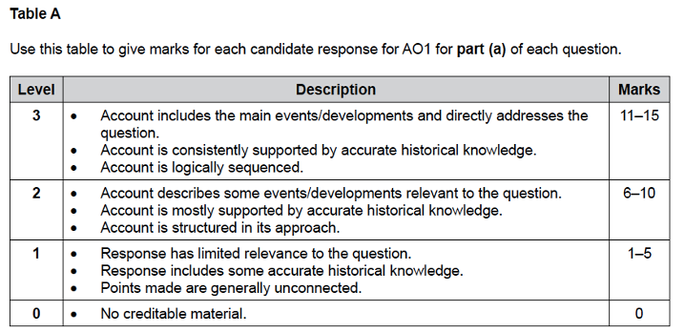

Highlight some of the key words of what you are expected to do?

What are you going to make sure you do?

Here is the marking schedule for the second task.

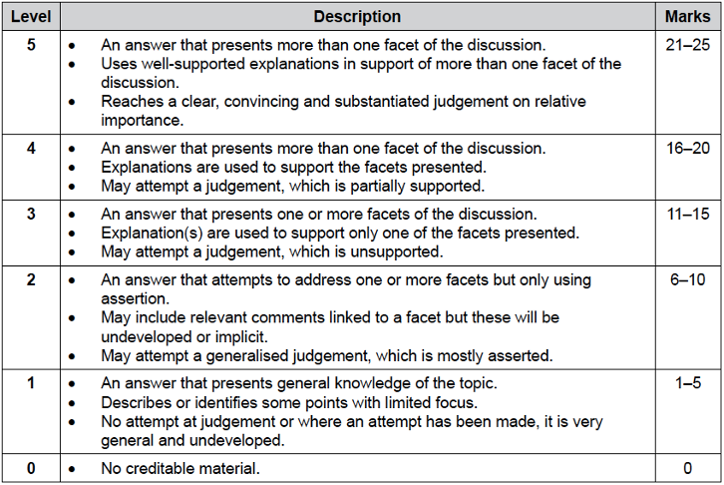

Highlight some of the key words of what you are expected to do?

What are you going to make sure you do?

The second task will be answered in an essay format.

Often students are daunted by having to write essays. However writing an essay is not a particularly difficult skill. History like other disciplines has a set of rules that should be followed; once you know these rules then writing becomes very easy.

Knowing WHAT to write comes from your understanding acquired in class and from your own reading and preparation. Knowing HOW to write is a matter of practising known techniques. History aims to see if you can arrange your own knowledge into a recognised academic format.

The Key Principles of Good Essay Writing

∙ UNDERSTAND the topic (Before you do anything make sure you understand the question and exactly what the marker will want to read.)

∙ DECIDE what your argument will be. You need a very strong argument; you should aim to show a perceptive understanding of the topic. IGCSE will reward those who are bold in what they are saying.

∙ PLAN your writing (Before you do anything make sure you know exactly where your essay is heading. Some people work best by making a plan of where the essay is going on paper and there will space on the paper; others will not need to write down their plan as they have it all planned out in the head. Do not feel you have to plan your essay on paper, as this just wastes time. The important thing is know exactly where your essay is heading before you write it.)

∙ STRUCTURE your writing (An essay that is not structured is difficult to read and will not receive an achieved no matter how good the information is. You will be shown how to structure an essay later.)

∙ CHECK your writing (When you finish your writing, do not think you have finished the essay; you must proofread. By eliminating spelling mistakes and ensuring nothing is left out may be the difference between a middling or high grade.

Above all ***ANSWER THE QUESTION***

Before you start each paragraph always ask yourself am I answering the question. There is nothing a marker hates more than an essay that waffles on and doesn’t answer the question. Remember the marker has plenty of essays to mark; they do not have time to read a load of irrelevant material. Answer the question has accurately and succinctly as possible and you are going a long way towards getting a good grade. Try to make as many points as you can ; do not waste time over explaining things, just place things in the right context and the examiner will know what you are saying e.g.

‘The Germans were delayed in launching Operation Barbarossa’ rather than

‘Barbarossa was the German codename for their invasion of the Soviet Union, it took the Germans a lot longer to luanch it as they had problems in bringing their weapons to the front and because they were delayed fighting the British in Greece.’

**Other Pointers**

∙ Always use FORMAL LANGUAGE. This means writing in an academic and professional manner. Not including:

* Abbreviations (such as writing ToV instead of Treaty of Versailles or e.g. and etc.)
* Colloquialisms (words like ain’t)
* Slang (Writing using slang such as ‘Mussolini’s invasion of Abyssinia was really stink’)
* Clichés (Writing things such as ‘curiosity killed the cat’. It is a common fault of amateur historians to include overused phrases in their work, try to eliminate clichés out of your writing)
* Personal Pronouns (Do not write things like ‘In this essay I will talk about’. Do not indicate that you are writing the essay. The key to writing well is presenting facts so the reader will agree with what you are saying. You should always aim to show the reader what to think, not to tell them.
* Improper terms (Make sure you always use correct terms, for example always write ‘The Second World War’ not ‘World War II’)
* Once you have established the parameters of the question we need to think about how we are going to structure our essay. A good essay should ideally have four paragraphs, each having one main point. When you begin your essay plan out four main points that you believe will answer the question.
* In IGCSE you do not have to give a perfectly balanced essay. It is good to give a counter argument though as it will help to show that you have an in depth understanding of the entire course. Just make sure everything is linked to the question and keep anything off topic brief .
* You will be marked on:

1. Quality of Writing
2. Knowledge of the entire course
3. How good your argument is
4. Detail of supporting evidence

If anyone of those things is done poorly (e.g. a D level), it does not matter how good the rest of the essay is, you will receive a D.

**See if you can do that now for this question**

Give an account of events in the fall of France. (15)

Discuss the importance of the evacuation of Dunkirk? (25)

Now we have our main points we need to work out how we are going to arrange them. You can either arrange them CHRONOLOGICALLY or THEMATICALLY.

Chronologically means you arrange them in the order they happened i.e. you start with the first event that occurred and end with the last event that occurred. Thematically means that you are trying to answer a specific question and you start with the most important ideas first and end with your least important. WHAT WOULD IT BE BETTER TO ANSWER THE QUESTION ABOVE WITH?

Each paragraph should follow this structure:

**Point:** What is the main idea that you are trying to convey.

**Evidence:** What specific historic knowledge e.g. events or statistics support this idea. Three pieces of evidence is sufficient to support an idea.

**Explanation/Evaluation:** How does this prove your point and how conclusive is your evidence.

We are now ready to begin our essay

*The first thing we do is right the introduction. This should be about four or five sentences. The purpose of the introduction is to show exactly where your essay is heading. There should be nothing in the rest of your essay which was not implicitly mentioned in your introduction. You should begin with a sentence that clearly explains your argument, then run through your main points that the essay will cover. Make sure you do not go into very much detail they just need to be mentioned. SUPPORTING POINTS BELONG IN THE MAIN BODY.. Some people find it easier to write the main body of their essay and leave a gap to write their introduction at the end; this is perfectly acceptable.*

*The main body is where you show the depth of information you know about this topic. It is an opportunity to impress the examiner. As stated you should try and have three to four paragraphs in your main body in IGCSE. Each paragraph should begin with a sentence that outlines the main argument/point for that paragraph. This should be followed with three or four sentences of your evidence and an illustration of how this evidence supports your point. The final sentence should be used to conclude the paragraph and link forward to the next paragraph. EACH PARAGRAPH NEEDS ONLY ONE CENTRAL IDEA*

*Your conclusion should be shorter than your introduction, and should highlight what was the main point of your essay. It should not be a reiteration of your introduction. The conclusion is not the time to introduce new ideas, it should merely be a summary.*

**Task:** Now you know how to construct an essay have a go at answering the above question in an essay format. Your answer should be around 500 words.

DO NOT USE THE INTERNET

_______________________IGCSE HISTORY ESSAY CHECKLIST_________________________

|  |  |  |  |
| --- | --- | --- | --- |
|  | 1st Check | 2nd Check | Comments |
| Have I understood the question? |  |  |  |
| Does the first sentence of the introduction address the question? |  |  |  |
| Have I made a clear decision about what my answer will be? |  |  |  |
| Is it clear what ideas you will use for your paragraphs in order to answer the question? |  |  |  |
| There is no supporting evidence included in your introduction. |  |  |  |
| Does each paragraph have one main idea in the first sentence |  |  |  |
| Have you explained how your paragraph links to the question? |  |  |  |
| Have you included evidence and examples to support your explanations? |  |  |  |
| Does each paragraph link together to make a cohesive entire whole? |  |  |  |
| Is there any thing off topic and are any counter arguments comparitive to the question topic. |  |  |  |
| Have you used formal language? |  |  |  |
| Have you been concise in your writing? |  |  |  |
| Did you follow a logical method in how you answered the question? |  |  |  |
| Have you showed that you understood the First World War as a whole and how this question fits into it or have you shown the inter relationships at work in the question given? |  |  |  |
| Does your conclusion sum up your argument without being a repeat of your introduction? |  |  |  |