________________________________Barriers to Quick Victory________________________________
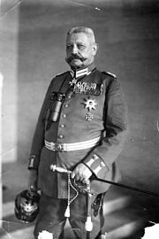
Explain how each of these factors is going to prevent
a quick victory in the First World War?

Mindset of the Generals

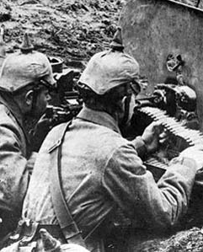
The invention of the Machine Gun

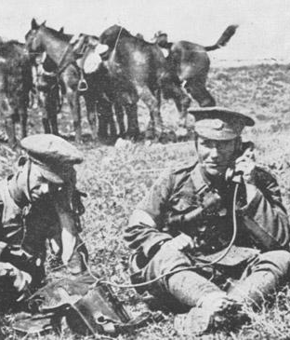
Communication Equipment

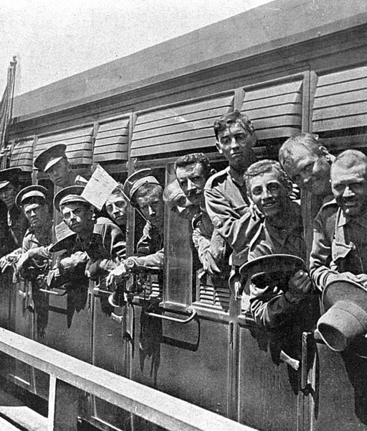
Transport

