___________________________________Olaudah Equino_______________________________

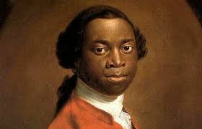

When I looked round the ship too, and saw a large furnace of copper boiling, and a multitude of black people of every description chained together, every one of their countenances expressing dejection and sorrow, I no longer doubted of my fate, and, quite overpowered with horror and anguish, I fell motionless on the deck and fainted….I now saw myself deprived of all chance of returning to my native country, or even the least glimpse of hope of gaining the shore, which I now considered as friendly: and I even wished for my former slavery in preference to my present situation, which was filled with horrors of every kind, still heightened by my ignorance of what I was to undergo. I was not long suffered to indulge my grief; I was soon put down under the decks, and there I received such a salutation in my nostrils as I had never experienced in my life; so that with the loathsomeness of the stench, and crying together, I became so sick and low that I was not able to eat, nor had I the least desire to taste any thing. I now wished for the last friend, Death, to relieve me; but soon, to my grief, two of the white men offered me eatables; and, on refusing to eat, one of them held me fast by the hands, and laid me across, I think, the windlass, and tied my feet, while the other flogged me severely. I would have jumped over the side, but I could not; and, besides, the crew used to watch us very closely who were not chained down to the decks, lest we should leap into the water; and I have seen some of these poor African prisoners most severely cut for attempting to do so, and hourly whipped for not eating.
How would people in Britain react to this account?

