The End of Appeasement

In your groups explain how each of these six events contributed to the end of the Policy of Appeasement

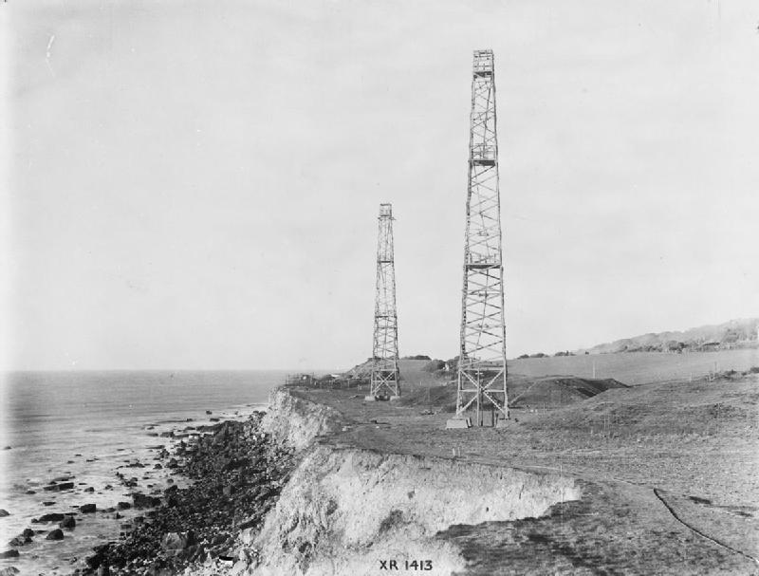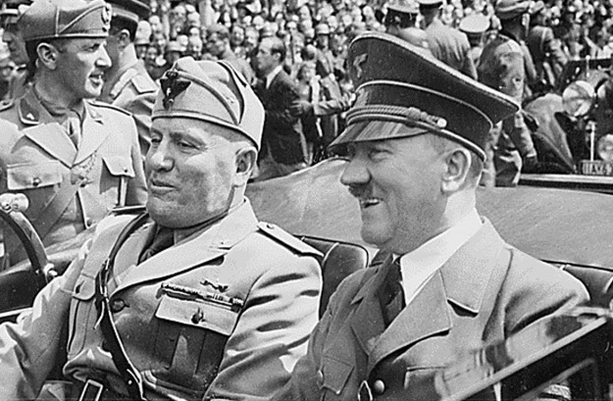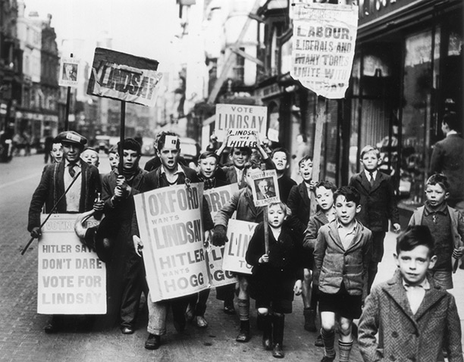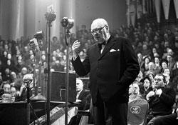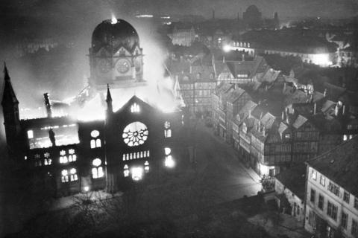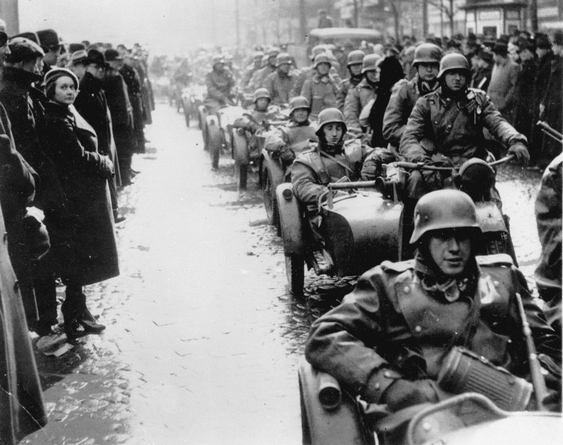Prague Coup: March 1939 Churchill’s Speech: October 1938

Kristallnacht: November 1938 Oxford By-Election October 1938

Pact of Steel: May 1939 British Defenses in 1939