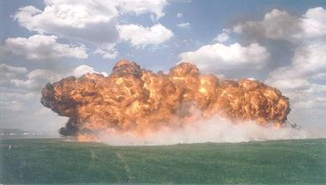
Beginning of the Vietnam War

What was the importance of Dien Bien Phu?

Why would the US not hold elections to unify Vietnam?

How important was Ho’s actions in keeping Vietnam separate?

What was the Viet Cong?

How important were MacNamara and Westmoreland?

What were the Viet Cong Tactics?

Why might they be effective?

What was the Gulf of Tonkin Resolution?
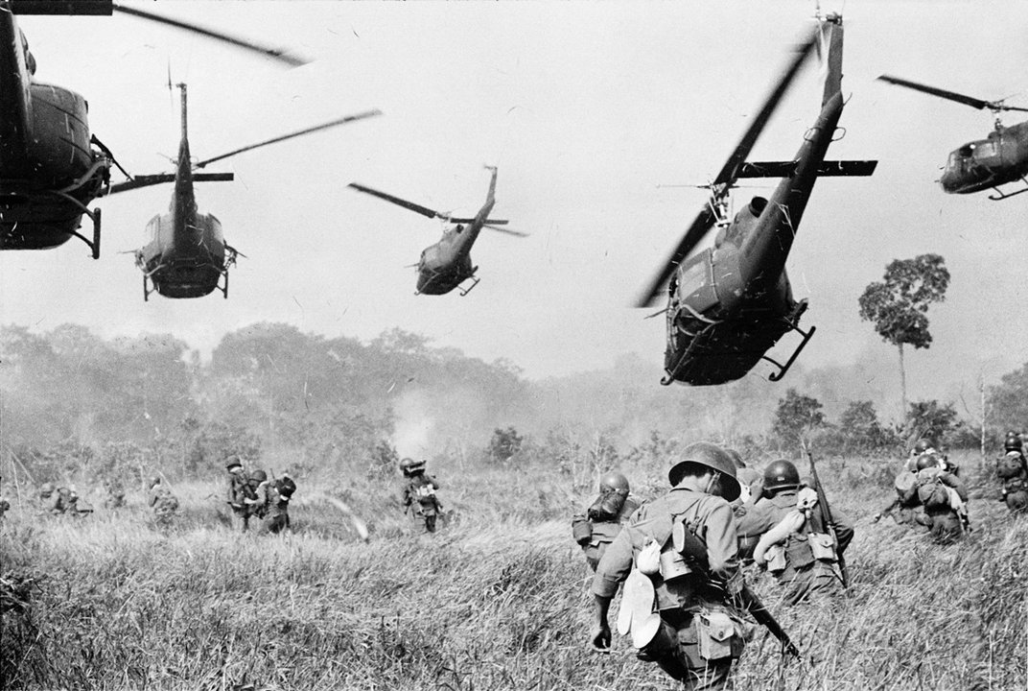

Why would the US send ground troops?

Why would it turn into a quagmire?

Why would Ia Drang be classified as a North Vietnamese victory?

What was the Ho Chi Minh Trail?

How is Sino-Soviet relations effecting the war?

What risks is America taking in its bombing?

How great is the opposition to the war?

How serious was the Tet Offensive?

What problems did the US have by 1968?

