_______________________The Evacuation of Dunkirk: May-June 1940____________________

On 25 May, Anthony Eden gave the British commander, Viscount Gort, permission to prepare the evacuation of the BEF. Initially it was believed that at most 45,000 could be saved. Instead, the warships of the Royal Navy and assorted civilian craft had taken off some 338,000 Allied troops, of whom 193,000 were British and the rest French. Some 80,000 soldiers, mostly French, were left behind due to confusion and the slowness of their commanders to withdraw them. During the campaign in Belgium and north-eastern France, the British had lost 68,000 men. Almost all their remaining tanks and motor transport, most of their artillery and the vast majority of their stores had to be destroyed.

Write an account of the British evacuation of Dunkirk.
The First Days of the Evacuation
On 26 May, with German panzer groups paused on the pocket perimeter the evacuation of the British troops began in earnest

While the British navy and RAF deserve much credit for the early success, the bravery of the Anglo-French defenders often critically short of ammunition was critical.

The Political Decision
Unsettled by French defeatism the British began proceedings to remove the BEF from France on 17 January.

While Britain made the correct decision to abandon their ally. The recriminations of the decision and the handling of the evacuation would destroy Anglo-British relations for the remainder of the war.

Final Days of the Evacuation
On 29 May, sensing that the British escape may eventuate the German forces pursued their attack with greater vigour.

Despite the success of the evacuation, the campaign in France had been a disaster. If Germany could establish an air or naval parity that would allow them to land their forces, then Britain would be defeated.

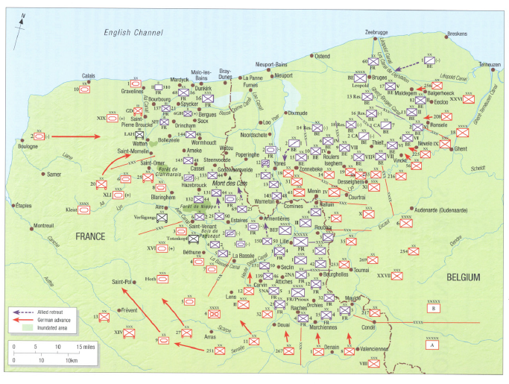

Look at the map of the situation when the evacuation was decided. What potential difficulties are there for each side?

Watch the scene from the movie Attonement. What does this tell us about the evacuation?

Why did Hitler pause fifteen miles from Dunkirk for 36 hours on May 24, 1940?

- He may have stopped the armor advance to allow the British to escape, hoping to coax them into peace negotiations thereafter.
- Kleist’s two panzer corps urgently needed maintenance work on their vehicles. His panzer group had already lost half its armoured strength. In three weeks, 600 tanks had been destroyed by enemy action or had suffered serious mechanical trouble, which represented just over a sixth of the entire German force on all fronts.
- He wanted to give time for the infantry to catch up with the panzer divisions. The Germans used their tanks for rapid breakthroughs. With the British so close to the coast, a different fighting was required. Only sixteen divisions out of 157 were fully motorized. All the rest had to rely on horses to pull their artillery and baggage.
- The German forces dealing with the Dunkirk pocket were disorganised: they were under the command of two army groups, three armies, and 15 corps. Each had its own objectives, means and ways of destroying the enemy before them. There was no clear plan. Operations, orders of battle, lines of responsibility and even the overall objectives could be changed and adapted on a daily and ad hoc basis. It was not until 30 May that the German forces were reorganised
- Remembering the fighting for that same ground in the First World War, he may not have wanted to risk another bloodbath.
- Guderian’s armor spearhead might be vulnerable to counterattack outside Dunkirk.
- Neither Rundstedt nor Hitler believed that the Allies could execute a large-scale evacuation.
- Hitler did not fear the British Army as much as he did the French. The British committed only ten divisions compared to France’s 95 divisions. The ratios of aircraft for the two allies were similar. Thus for Hitler, destroying the French ground and air forces in battle took priority over the British distraction at Dunkirk.
- Hitler accepted Goering’s assurance that the Luftwaffe could finish off the BEF, which no longer threatened German strategic purposes; and the panzers needed rapid refit before being urgently redeployed against Weygand’s forces. Germany was short of tanks. Why expend material that could be deployed against the Soviet Union?
- He did not believe that Britain could mount a seaborne evacuation without air superiority.
- Spirited allied counter attacks on 17 and 21 May, convinced Hitler that neither enemy was beaten. He worried that a repeat of the 1914 ‘miracle on the Marne’ could occur. The British Matilda tanks could not be destroyed by the German armor. General Erwin Rommel had improvised, turning his 88mm anti-aircraft guns horizontal to knock out the 16 British tanks. But his innovation had not yet become tactical doctrine.
- On May 25, the British had a piece of luck. A small British patrol saw a German staff car approaching. A British sergeant, armed only with a pistol, fired at the car, killing the driver. The car crashed and the passenger, a German officer, leapt out and fled. Left in the car was a briefcase containing detailed plans for how the Germans intended to smash through the British lines in Belgium and then thrust directly to Dunkirk. British reinforcements were immediately sent to thwart the attack.
Why else could the British escape?

- Churchill ordered a plan devised on 17 May.
- Already non-essential personal had been evacuated.
- They adapted quickly to the slow rate of evacuation.
- Stating that the halt order is why the Allies escaped ignores the tremendous stubbornness with which the defenders – both British and French – held the Dunkirk pocket. There are several examples to illustrate this claim. For instance, on May 27th, the British 2nd Division, while facing four German divisions fought hard to keep the line of retirement open. The Germans themselves acknowledged the tenacity of the defenders and the fact they were not able to make “any notable headway to the east or north-east” as they tried to trap the Allied forces through the Poperinghe-Kemmel line
- The Admiralty contacted the volunteer owners of small vessels, such as yachts, river launches and cabin cruisers. They were told to rendezvous, first off Sheerness, then off Ramsgate. Some 600 were used in the course of Operation Dynamo, almost all crewed by ‘weekend sailors’, to augment the force of over 200 Royal Navy vessels.
- The RAF provided alternating waves of Spitfires and Hurricanes beginning at dawn each day. These would launch at 50-minute intervals to cover the French coast in squadron strength, typically 12 aircraft.
- Heavy cloud and mist with calm seas aided the evacuees.
- Belgian roads were clogged with troops and refugees and, coupled with the late start,
slowed the German approach to Dunkirk.
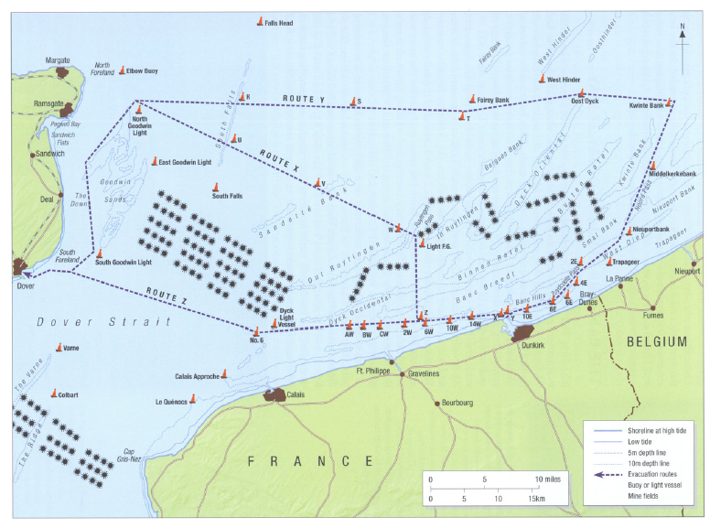

‘Hitler’s actions allowed the British to escape at Dunkirk.’ How far do you agree with this statement? Explain your answer.
Support | Against
First Idea | First Idea
Second Idea | Second Idea
Evaluation

Whilst Winston Churchill remarked that “wars are not won by evacuations,” the ‘miracle of Dunkirk’ boosted British morale.

Evaluation:
The unexpectedly quick victory in France, but without destroying the British army gave Hitler a strategic problem.

Evaluation:

The evacuation destroyed the already fragile relations between the Britain and France and the bitterness engendered in the French remained for the remainder of the war.

Evaluation:

The evacuation while preserving the British army, meant it would be years before it would be an effective fighting force.

Evaluation:

Evaluate the significance of the British evacuation of Dunkirk.

