The Russo-Polish War and the Treaty of Rapallo

*Was this a failure of the League of Nations?*

1. Watch the Video on the Russo-Polish War. Who does the creator of the video show a bias towards and how can we tell?

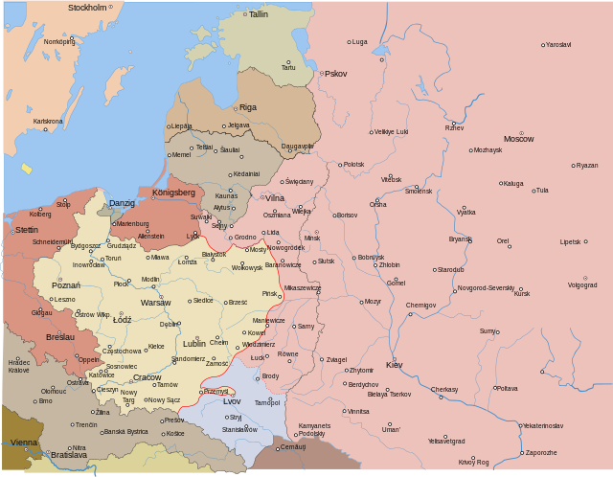

Poland after Versailles

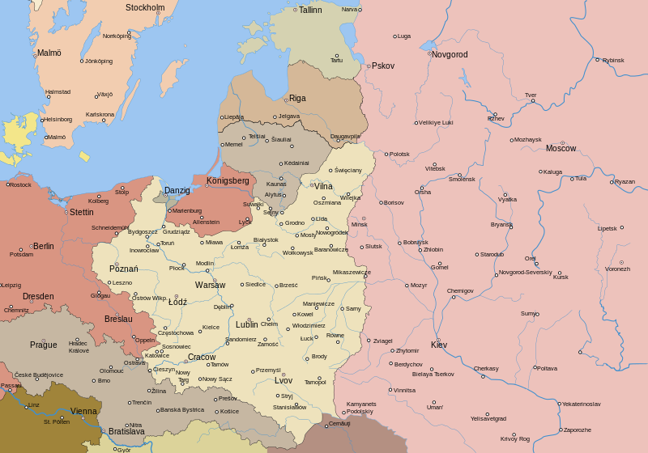

Poland in 1921

1. Have a look at the two maps above. Who was the main beneficiary of the war and how does that contrast with the video you have just seen?

Reasons for War Reasons not for War

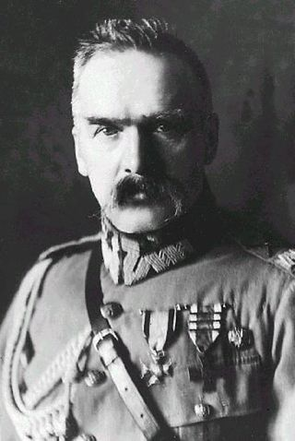

Jozef Pilsudski

Reasons for War Reasons not for War

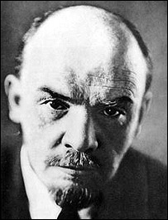

Vladimir Lenin

Does the League of Nations have a responsibility to Act? Why do you think that the League of Nations did not intervene?

Treaty of Rapallo (1922)

Should the League of Nations Intervened?

What did the Treaty say?

What did Germany and Russia both have in common?