The League of Nations

The Covenant of the League of Nations had 26 articles that its members agreed to abide by.
These can be summed up in four major aims

Who Joined?

Initially 42 countries joined the League of Nations and this later increased to 59. Highlight the table for the Big Powers Below.

Year | 20 | 21 | 22 | 23 | 24 | 25 | 26 | 27 | 28 | 29 | 30 | 31 | 32 | 33 | 34 | 35 | 36 | 37 | 38 | 39 40
Britain
France
USA
USSR
Germany
Japan
Italy

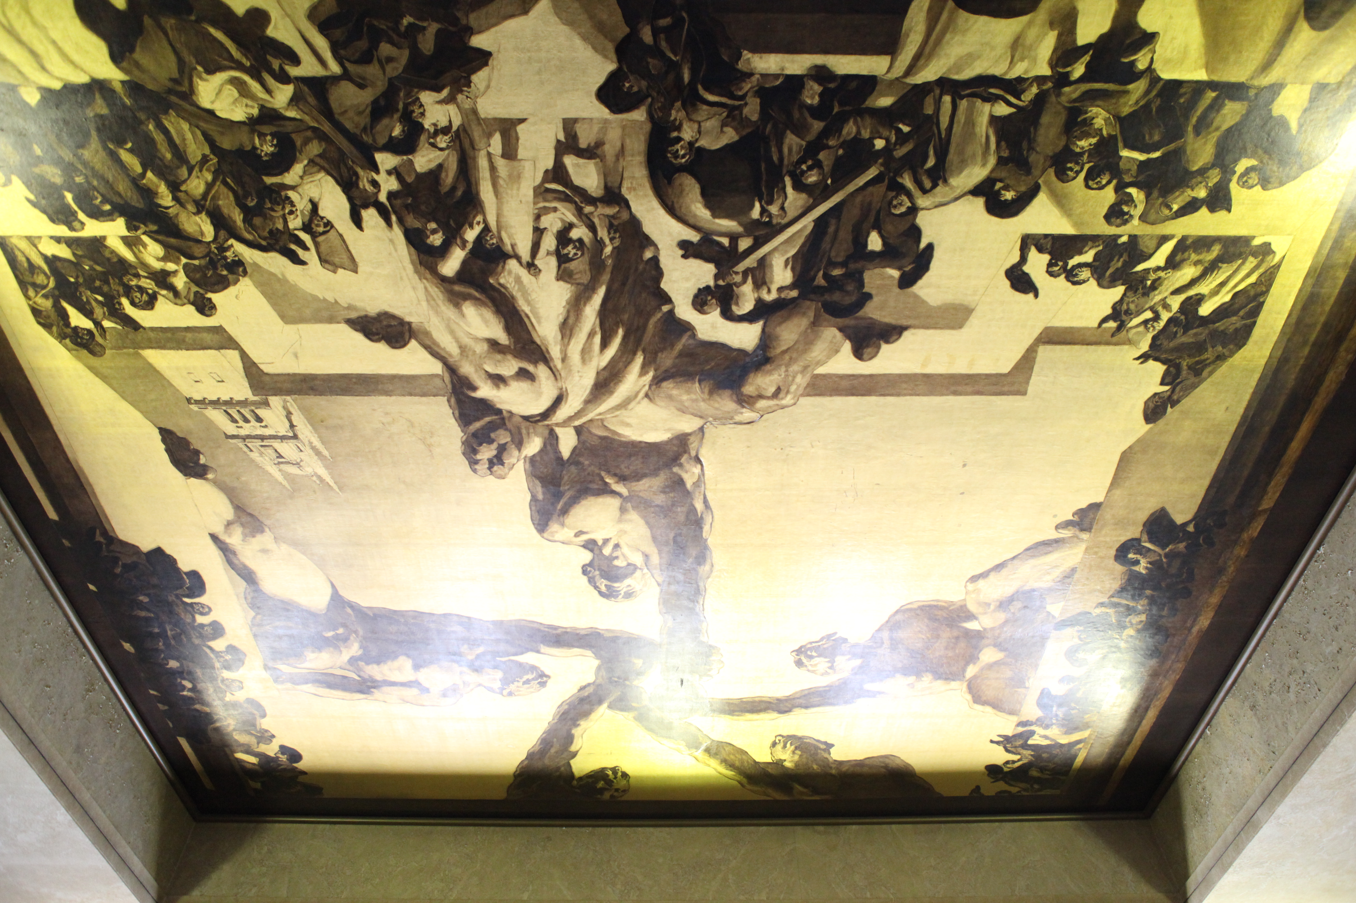
This is the ceiling of the Assembly building in Geneva. What do you think the meaning behind it is?

How did weaknesses in the League of Nations structure make its failure likely?
1.________________________________________________________________________________________________________________________________________________________________________________________________________________________________________
2.________________________________________________________________________________________________________________________________________________________________________________________________________________________________________
3.________________________________________________________________________________________________________________________________________________________________________________________________________________________________________
4.________________________________________________________________________________________________________________________________________________________________________________________________________________________________________ 5.________________________________________________________________________________________________________________________________________________________________________________________________________________________________________
6.________________________________________________________________________________________________________________________________________________________________________________________________________________________________________
7.________________________________________________________________________________________________________________________________________________________________________________________________________________________________________
8.________________________________________________________________________________________________________________________________________________________________________________________________________________________________________

Council of Ambassadors

As you go through, you might see that at times you will hear a matter referred to the Conference of Ambassadors. Most notably Teschen, Vilnius, Memel and Corfu. The Conference of Ambassadors, was the replacement for the imperial war council that made the Treaty of Versailles after the Big Three left Paris. It was primarily still in existence to deal with matters or disputes that related to the Treaty of Versailles (although Mussolini cleverly used it in the Corfu crisis, as the original dispute was between Albania and Greece). The USA remained but only as an observer. It was rarely called after 1925 and was disbanded in 1931.
- When evaluating whether the League’s structure undercut its effectiveness, remember, that the League’s weaknesses were understood at the time.
- When the USA rejected membership in March 1920, Britain realised that the agreed structure would be unsustainable. They understood that the League could never be powerful enough to confront the USA, nor would that be in Britain’s interests. Without the US, economic sanctions would be ineffective and would possibly see Britain needlessly lose foreign markets to the Americans.
- Both Britain and France proposed a looser organisation that could include the USA, Germany, and the USSR.
- The issue was that the League of Nations had been charged with enforcing the Treaty of Versailles. In particular it had been given a specific role overseeing the mandate system and direct governance of the ports of Memel and Danzig and the Saar for the next fifteen years.
- France’s desire to ensure Versailles’ terms were rigorously enforced unnerved Britain, who felt the association of the League with the Treaty reduced its credibility as an international organisation.

Permanent Court of Justice at The Hague
What did it do?

Who sat on it?

Limitations to its powers….
International Labour Organisation
What was its purpose?

How often did it meet and who was on it?

Limitations to its powers….

Assembly
What was the Assembly in charge of?
1.

2.

3.

4.

How often did it meet?

How were things decided?

Secreteriat

What was the job of the Secreteriat

Council
Who were the Permanent members?

How many temporary members were there?

How were disputes supposed to be solved?

If this did not work what was powers did the Council have?
1.

2.

3.

Committees
Child Welfare

Drug Trafficking

Health

Refugees

Women’s Rights

Commissions
Mandates

Danzig

Saar

Reparations

Disarmamanet

