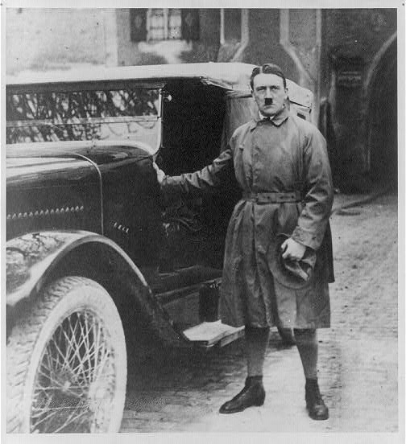
_________________________Rebuilding the Nazi Party: 1924-1929______________________
The NSDAP was re-established and re-organized as a traditional political party that could participate in the Reichstag elections.
Why? That there was no possibility of overthrowing the government. He needed greater respectability in a wider audience.

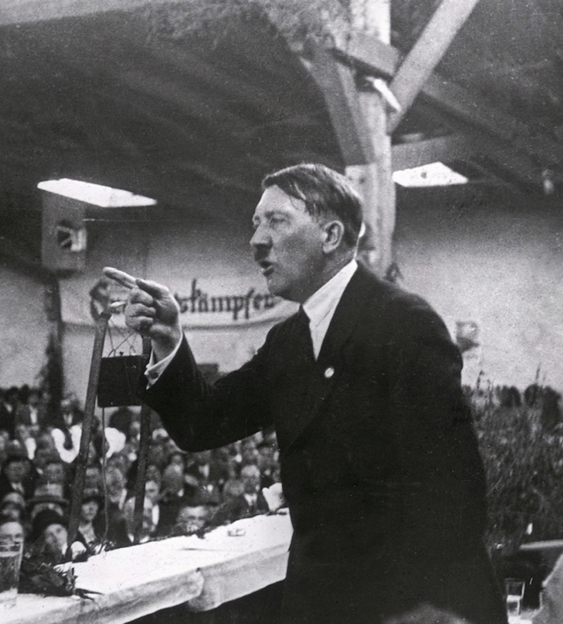
Inspired by the Italian Fascists’ personality cult of Mussolini, Hitler adopts the so-called leader principle, which means that he is the undisputed leader of the Nazi party—his word is now law in the party.
Why? It is the beginning of his extreme narcissism. He believes that the party can only survive under his authority.

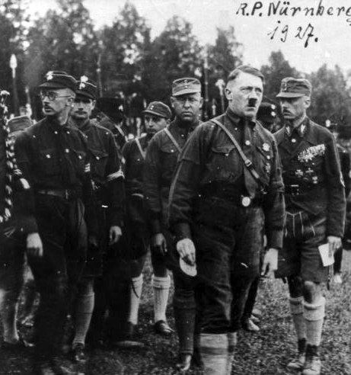
He established a personal bodyguard unit that was named Schutzstaffel (security unit or SS).
Why? He didn’t fully trust the SA – they had been too independent. They could have overthrown him. They were a bit embarrassing – too old.

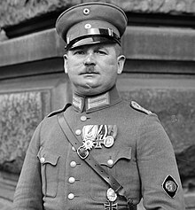
There was to be no more cooperation between the SA and other paramilitary groups. Ernst Röhm either was dismissed or left. He left Germany to train the Bolivian army.
Why? He was insufficiently deferential. Completely loyal.

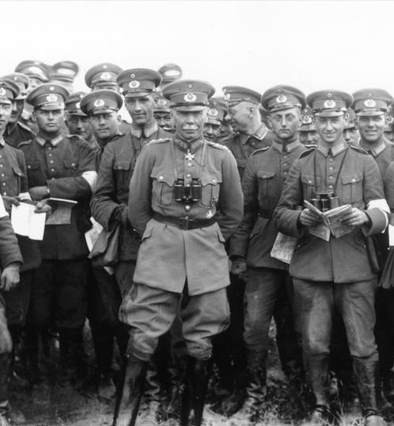
Any future moves required the support of the Army and key institutions.
Why?
They are not powerful enough otherwise.

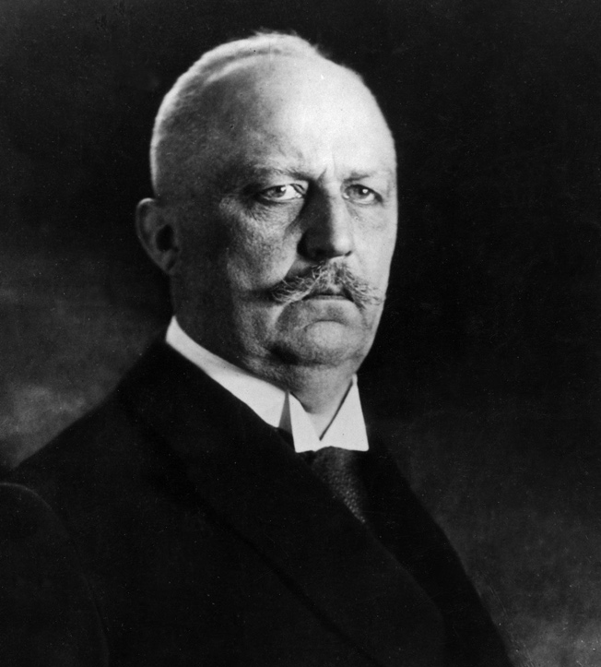
Hitler persuaded the increasingly erratic and extreme (he had become fervently anti-Catholic) to stand in the 1925 Presidential Election.
Why? He knows he will lose, 1% vote. Humiliating and he disappears from public life.

Changes in the 1920s
- Hitler was not allowed to speak in public in most parts of Germany until 1927 and in Prussia until 1928. This benefited him, as he now focused his attention on gaining complete control of the Nazi party.
- The first party rally was held at Nuremberg in 1926, attended by 8000 Brownshirts.
- The greeting Hail Hitler was made compulsory in 1926.
- Multiple memberships in parties were forbidden.
- Also, in 1926, the Hitler Youth was founded. It was originally a recruiting tool of the SA, but in 1929, it was reorganised to compete with other youth organisations in the Weimar Republic.
- The Hitler Youth was never particularly popular. But the National Socialist German Student’s League, also founded in 1926, quickly made headway in the nation’s universities, controlling all student associations by 1931.
- There were groups for civil servants, for the war-wounded, for farmers, and for many other constituencies, each addressing its particular, specifically targeted propaganda effort.
- The party was reorganised into regional offices matching Weimar electoral boundaries.
- Copying the Communists, each region was to have its own propaganda cell. “The local party chapters were explicitly subordinated to the regional chiefs (Gauleiter), who were in turn selected by Hitler. The local party chapters were required to submit monthly reports on their propaganda activities to the regional party leadership, where the Gauleiter and his propaganda staff would then pass them on to the Reich Propaganda Leadership in Munich. In 1927, a national handbook was produced to standardise procedures and a calendar.
- Gregor Strasser, who had proven himself the most politically astute of the Nazis before the Putsch, was sent to the North on a recruitment drive. He found willing recruits in the Ruhr, who supported his ideas about the nationalisation of industry.
- Despite Hitler’s repeated insistence that politics was a matter for men, there was now a Nazi women’s organisation, the self-styled German Women’s Order, founded by Elisbeth Zander in 1923 and incorporated as a Nazi Party affiliate in 1928.
- The old remnants of the Frei Korps and secret societies were cleared out and replaced by young zealots. Even at the top, the entire leadership was under 40.
- In general though, the Nazis struggled to make inroads into SPD and KPD strongholds.

In what ways did Hitler change his tactics following the Munich Putsch?

Idea One | Idea Two

The 1928 Election
Why did the Nazi Party have little success in elections before 1930?
Idea One | Idea Two
Why were the Nazis encouraged by the 1928 election results?

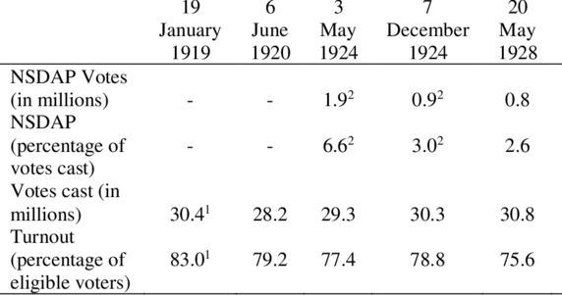

- After 1928, they targeted the Northern German peasantry, whose economic position worsened throughout the 1920s. The Nazis argued that the remnants of the Aryan or Nordic race could still be found on the soil among those German small farmers. In the future, these few farmers should have a pivotal political and social role as a new leadership elite. This ancient peasantry should also provide the basis for a eugenics program which would purge the country of ‘ínferior’ races.
- The referendum against the Young Plan in 1929, brought the Nazis a greater respectability and national precense.
Goebbels
- His propaganda headquarters in Munich sent out a constant stream of directives to local and regional Party sections.
- He was the only Nazi who could match Hitler’s speaking power. He avoided vague philosophical and rhetorical declamation and instead spoke and wrote with a remarkable clarity and openness mixed on occasion with sarcastic humour.
- He became frustrated with Hitler’s refusal to embrace his leftist policies, but a weekend away together, ensured his eternal loyalty.
- He used traditional means such as newspapers, posters and leaflets. However, he also employed new types of communication technology, such as radio and film.
- Political choices were presented in black-and-white terms, with no room for compromise or a middle position. If one stood with Germany and against Versailles, then one must side with Hitler. Otherwise, one was a traitor. Goebbels made no distinction between the SDP and KPD.
- Truth ought to be suppressed if it serves the Nazi cause (the great lie). Every false assertion can be justified; the end justifies the means—and the aim is to gain power.
- A key inspirer of both Goebbels and Hitler is the French sociopsychologist Gustave Le Bon. Le Bon advanced his theory of “mass psychology.” The theory is based on assumptions that “the masses” are profoundly irrational, dominated by feelings and instincts, and that the single individual loses their rationality and individuality when they become part of the masses. The masses can, therefore, be controlled by leaders who are capable of playing on their irrational strings.
- Goebbels was a classic demagogue or “seducer of the people.” He worked out how Nazism can be promoted or “marketed” to various sections of the population—what aspects of the party’s ideology and politics that ought to be emphasised, and what aspects ought to be toned down, or suppressed.
- The term Nationale Erhebung (national renaissance) was characteristic of this attempt to cloak the Nazi take-over with the language of restoration, tradition and continuity, reaching back beyond 1918.
- He would personally debate with other politicians. Notably in 1931 when he took on the KPD’S Walter Ulbricht. An event which descended into a brawl amongst the 4,000 attendees.
- By 1930, Goebbels had built an organisation of 1378 branches with 130,000 members.
Why was Goebbels important to Hitler?

Idea One | Idea Two

