______________________________________________________________Maoism in Africa________________________________________________
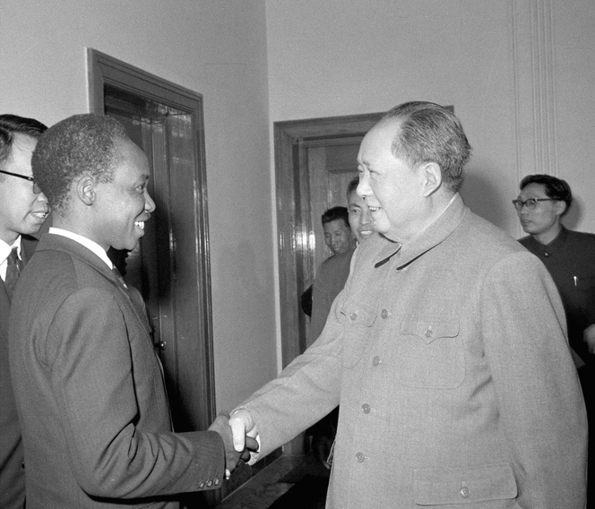
Use Julia Lovell, Maoism: A Global History, Vintage, London, 2019. Chapter Six
Evidence Two. What was the scale of Chinese economic and military involvement in Africa
Topic Sentence on why Mao felt he could export his version of Communism to Africa.
Evidence One. How much support did Mao give Julius Nyerere’s regime in Tanzania:
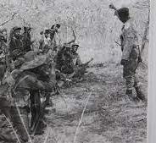
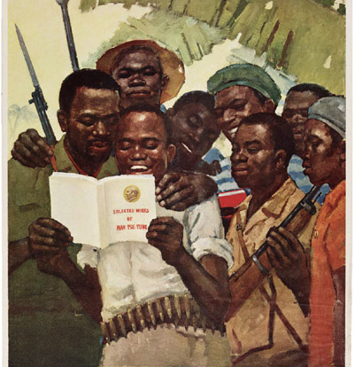
Evaluation. How far did the African aid increase Chinese influence in Africa?
Evidence Three. How valuable was China to Mugabe’s freedom fighters in Zimbabwe:

