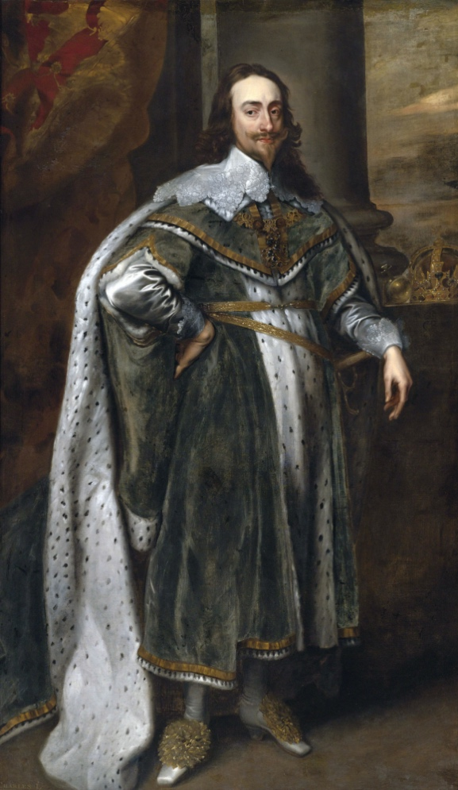

Charles’ accomplishments during personal rule were undone by his catastrophic religious policies in Scotland.

Still….

Charles first challenge upon his accession was funding an expensive war with Spain.

Still….

The disastrous 1629 parliament saw Charles begin his personal rule. These eleven years were the most successful of his reign as he implemented the policy of Thorough.

Still….

Forced to recall parliament in 1640, Charles then made a series of calamitous decisions that contributed to Civil War erupting in August 1642.

Still…..

Introduction:

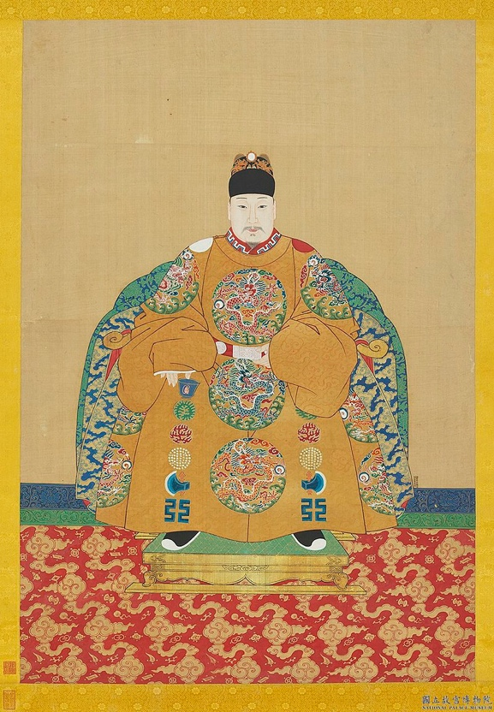

By 1605 the stasis within the court turned into a crisis as attacks from the Donglin party saw administrative positions unfilled.

Wan-li initially undercut his authority through divulging too much power to his Grand Secretary Zhang Zucheng.

Still….

While Wan-Li’s achievements do not extend beyond a credible stalemate in the 1590s Japanese war, it is hard to see how he could have achieved any ambitions given the constraints on Late-Ming emperors.

Conclusion:

The execution of Zhang failed to ease divisions with a self-engineered succession crisis increasing factionalism within the court.