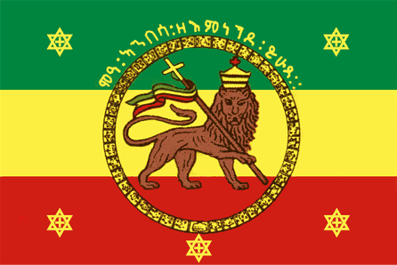
Where Was Abyssinia?

- The the only part of Africa that had not been colonised, Abyssinia was a country of 12 million people, which spoke 70 different languages.
- In 1896 its army led by Menelik II humiliated the Italians at the battle of Adowa. The Italians were forced to abandon their weapons and suffering losses of around 7,000 compared to 4,000 to 5,000 Ethiopians.
- Mussolini’s supported the nation in joining the League of Nations in 1923. Britain and other nations had opposed the move and initially Mussolini had agreed. Though it had a king it was ruled over by tribal lords and still practised both slavery (two to four million in the country) and feudalism. Britain had long disliked Abyssinia, due to the large number of slave raids that were conducted from their into its territory in Kenya and the Sudan.
- Mussolini then reversed his opinion and threw Italy’s full support behind the bid with Hallie Sellaise as King. Mussolini’s diplomatic experience would later prove problematic..
- In 1928 Abyssinia and Ethiopia signed a 20-year friendship agreement. Both nations signed the Kellogg-Briand Pact in 1929
- The capital Addis Abba did not have a sewerage system or running water and the electricity supply was sporadic.
- Disease was rife especially tuberculosis and leprosy. Garbage was dumped in the streets which encouraged packs of jackals and dogs.
- Abyssinia’s army had almost no modern equipment; soldiers were even seen attacking Italian tanks with their bare hands.

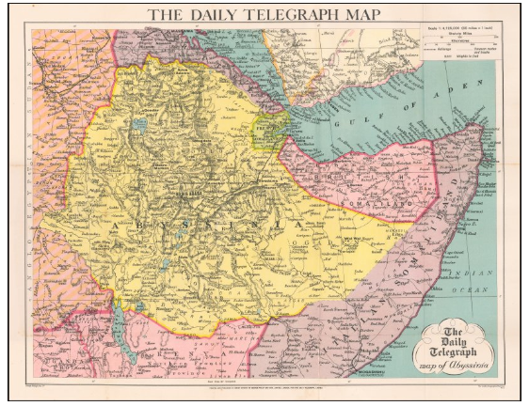
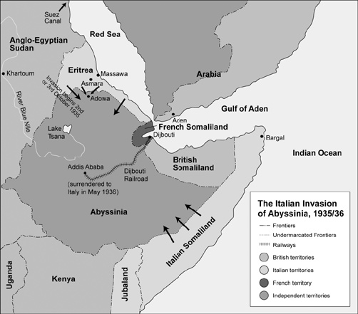

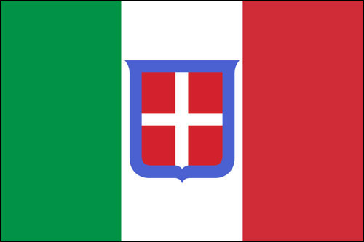
Why did Italy Want Abyssinia?

- Italy was late to the ‘scramble for Africa’ that occurred in the second part of the nineteenth century. Britain and France, had secured the continent’s more profitable areas, leaving Italy with Eritrea and Italian Somaliland on the Horn of Africa (Italy added Libya to their empire in 1911). Even tiny Belgium had more African territory than Italy.

- But Italy’s demands for Abyssinia was really just pride – Abyssinia was no Manchuria, it was poor, landlocked and short of natural resources. In no way could it play the classic role of a colony.

- Italy had been frustrated at the Paris Peace Conference and many on the right felt that their reward for joining the allies and suffering 600,000 deaths was not reflected in their gains.

- Mussolini had long held contempt for the League of Nations. His curious mix of bravado and inferiority meant that he had little use for diplomacy following the Treaty of Locarno in 1925. “Words are truly beautiful things,” Mussolini famously concluded, “but rifles, machine guns, ships, aircraft and cannons are even more beautiful.”
.
- Mussolini was also encouraged by the failure of the League of Nations to take action in Manchuria. For him the implications could not have been clearer. Collective security, which had prevented a Fascist annexation of Corfu in 1923, could no longer guarantee the territorial integrity of League member states nine years later. Following the Manchurian Crisis, Mussolini took direct control of Foreign Affairs and the Ministry for Colonies and purged the ministries of any potential supporters of the League.
As he told a large crowd in Naples in October 1931, the time was now clearly right for Italy to stake its own claim by extending its own revolutionary dynamic to include expansion overseas:

The plutocracies that govern so many nations have too many difficulties at home to be
seriously interested in our matters and in the new developments that we want to give to
our own revolution. But if there are elements who plan to disrupt the direct communion
between the regime and people, whether they are made up of groups or individuals, we,
in the supreme interest of the nation, will break them into tiny pieces.

- Italy had been fascist since 1922. The centre point of Fascism was national regeneration through violence, with war the only outlet for a country to demonstrate its virility; he regarded an aversion to violence as a sign of decadence and decay. He wished to turn the Mediterranean into an ‘Italian Lake.’ Capturing the raw materials of Abyssinia would assist future war efforts, provide a propaganda boost at home and consolidate Italy’s strategic position on the Gulf of Aden.

- Italy was suffering from the Depression, a war allowed Mussolini to divert attention from troubles at home.

- Mussolini wanted revenge for Adowa and he wanted to attack before Abyssinia modernised.

- Mussolini feared German Anschluss with Austria. He wanted a decisive victory to assert Italian power and discourage Hitler from provoking a war with Italy. Italy acted decisively to block the attempted German coup in Austria in 1934 and forced Hitler to back down – but he had received little support from the other guarantors of Locarno. He needed a show of force to discourage Hitler from attempting the same thing again.

- The decision to go to war in Abyssinia, was partly born of Mussolini’s frustration at the lack of any other valid alternatives. The Italian military was facing permanent shortages in 1930-1931, with it being only able to produce 200 aircraft a month with no carrier fleet available. It held only a tiny advantage over Mussolini’s desired enemy Yugoslavia, and they had an alliance with France, who had much stronger border defenses than the Italian forces. The impossibility of a European War, meant that Abyssinia appeared the only option, to fulfil fascist aims for national regeneration.

- In 1930, the Italians built a Fort at Wal Wal, well inside (80km) the agreed border between Abyssinia and Italian Somaliland. In November 1934, Abyssinian forces approached the fort and requested the garrison to leave (All Somalians). In early December, an Italian led force arrived in Wal Wal. An Anglo-Ethiopian Boundary commission was staying there, the British left and the Ethiopians stayed. There was a skirmish where 107 Abyssinians and 50 Italians were killed. it is unsure who started it but neither side took any steps to ease the confrontation.

- On December 6, Haile Selassie asked for the League’s assistance on December 8, Italy demanded an apology and financial compensation. In early January the League decided that neither nation was culpable for what had occurred.
- Italy was unwilling to accept this and began a calculated and prolonged military build-up in nearby Eritrea and Somaliland. It became obvious that there would be a war in the near future.

- In March 1935, Selassie requested the League to arbitrate in the dispute. By the beginning of August, the League had yet to agree who should sit in the Arbitration committee.

- September 28, Abyssinia mobilises its army and on October 3 the Italian Invasion begins.

Fascist Ideology
Revenge
Hatred of the League of Nations

WHY DID ITALY INVADE ABYSSINIA IN 1935?

Wal Wal Incident
Empire
Issues in Europe

Who is Who?

BRITAIN FRANCE ABYSSINIA ITALY

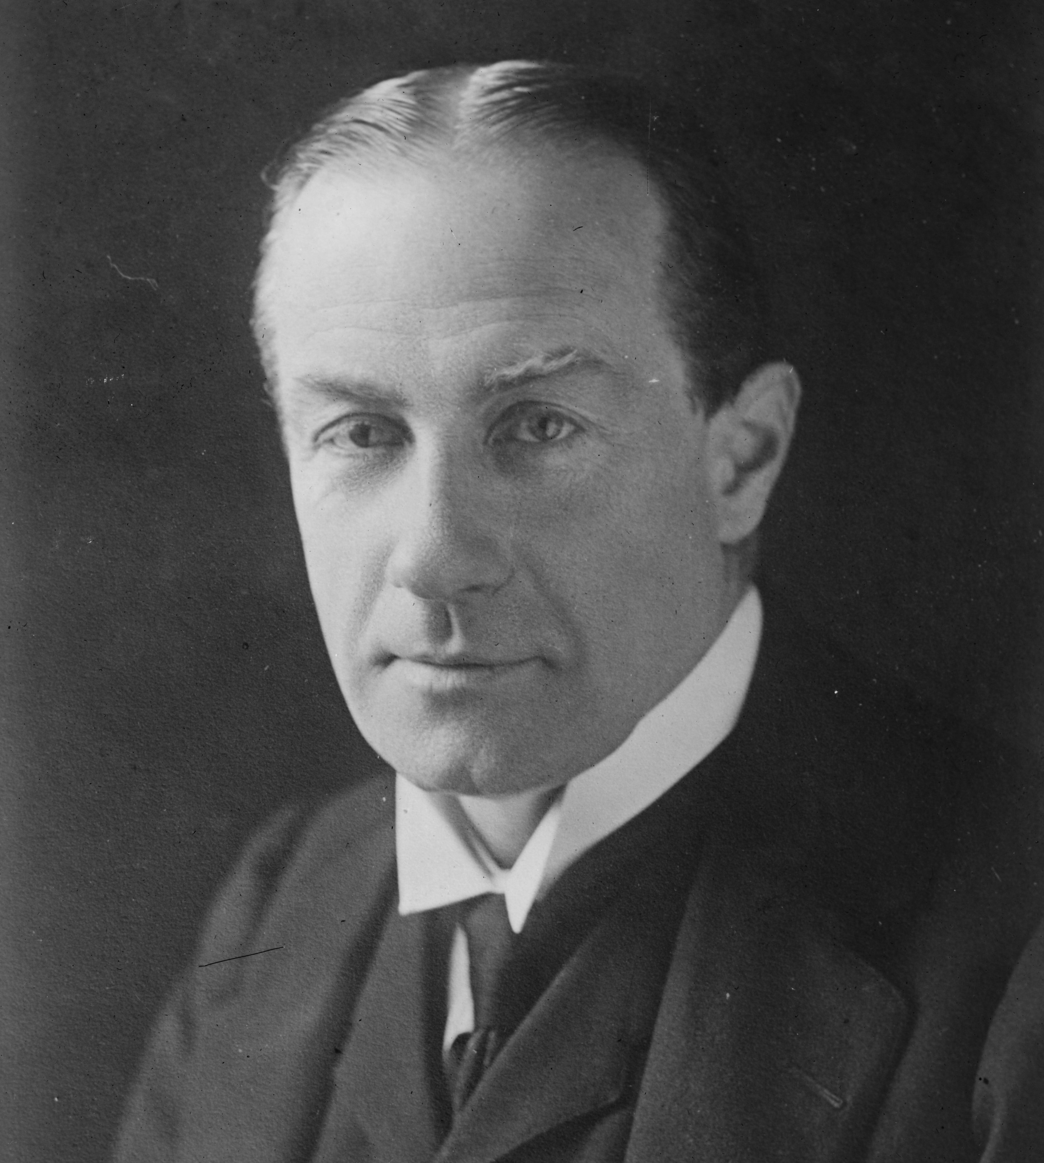
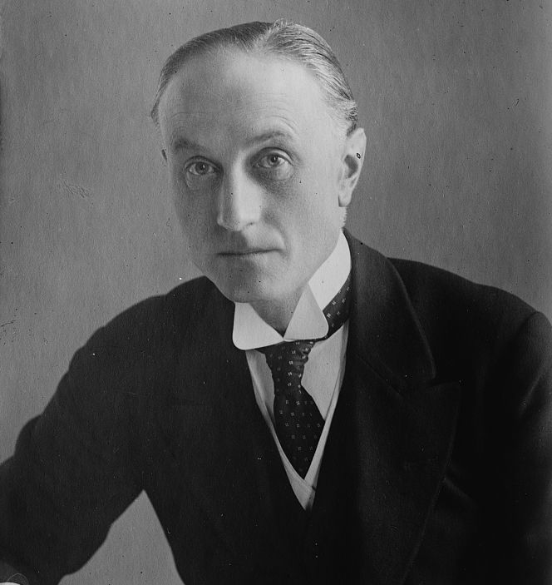
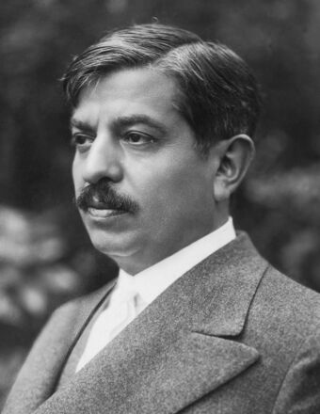
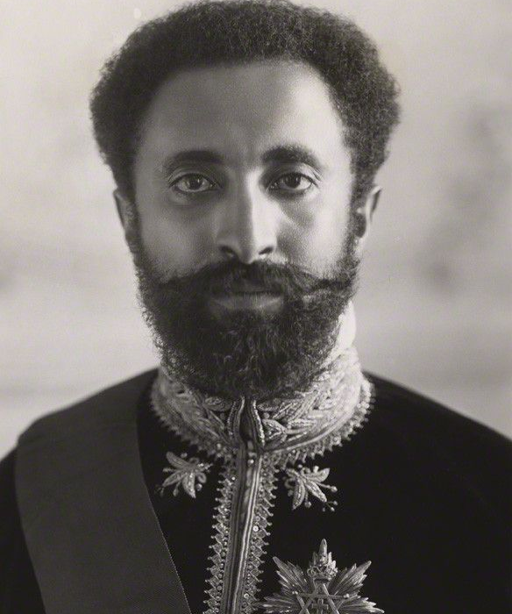
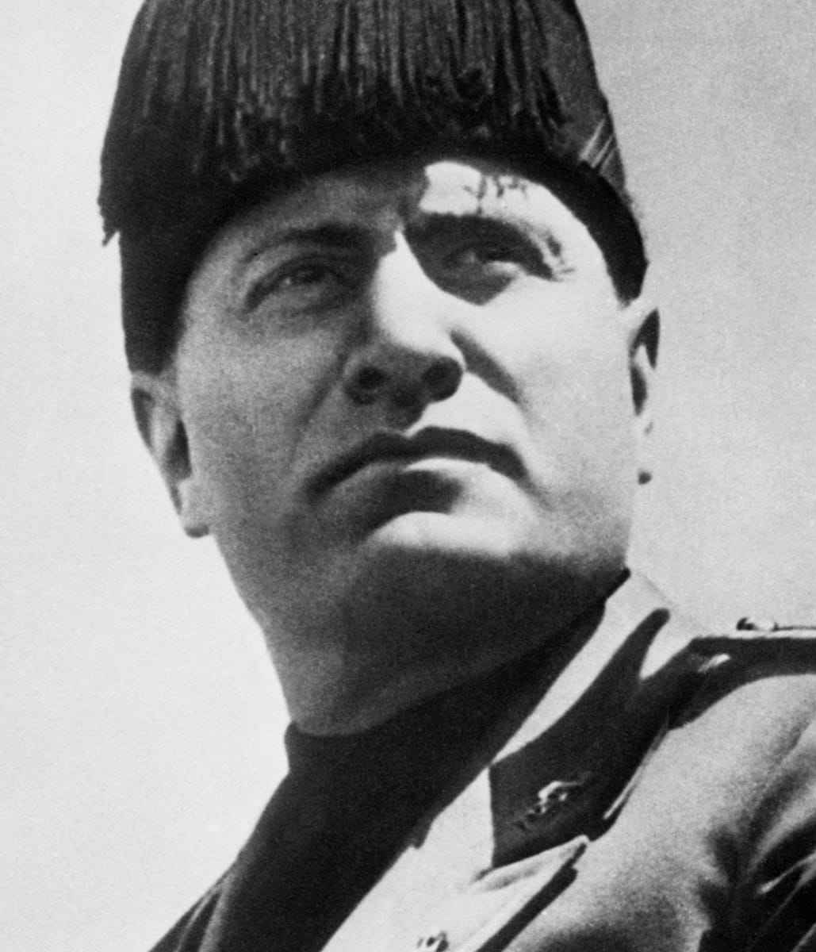

Stanley Baldwin Samuel Hoare Pierre Laval Haile Selassie Benito Mussolini
Prime Minister Foreign Minister Prime Minister Emperor Dictator

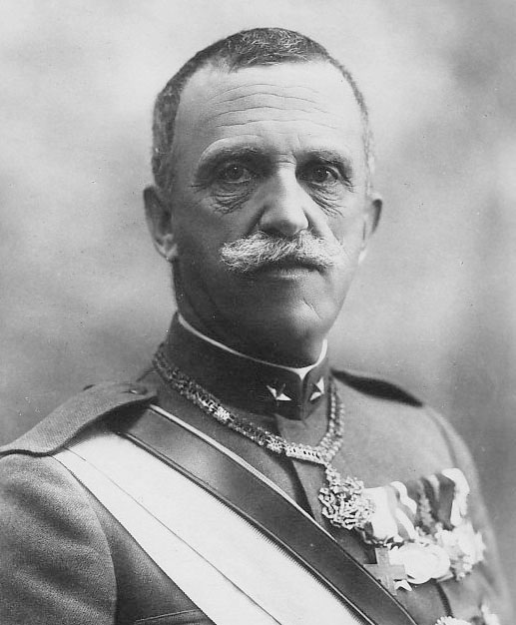
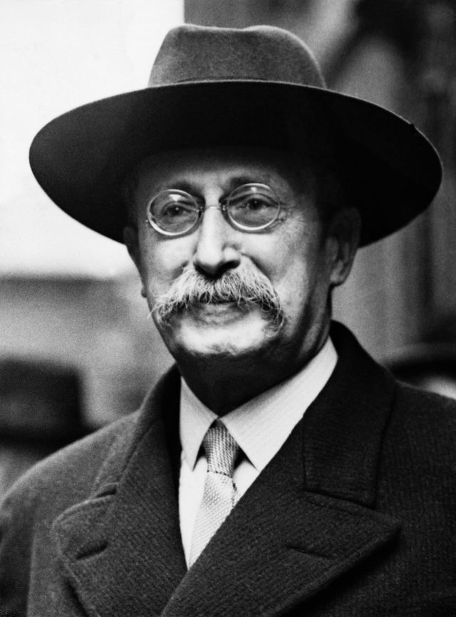
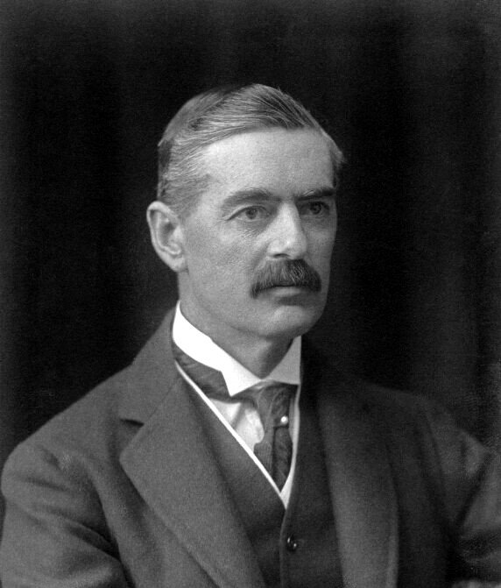
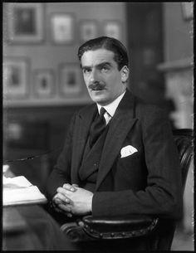

Anthony Eden Neville Chamberlain Leon Blum Victor Emmanuel III
League of Nations Chancellor of the Socialist Opponent King
Representative Exchequer
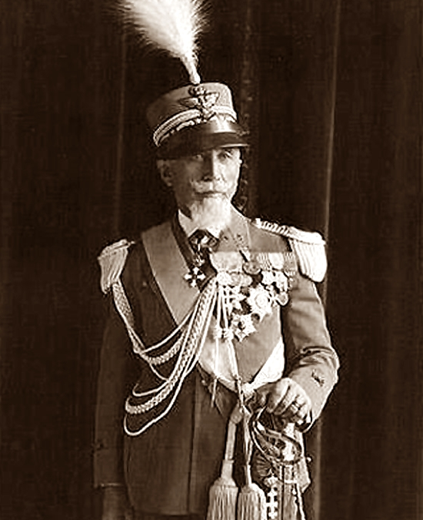

Emilio De Bono
Army Commander
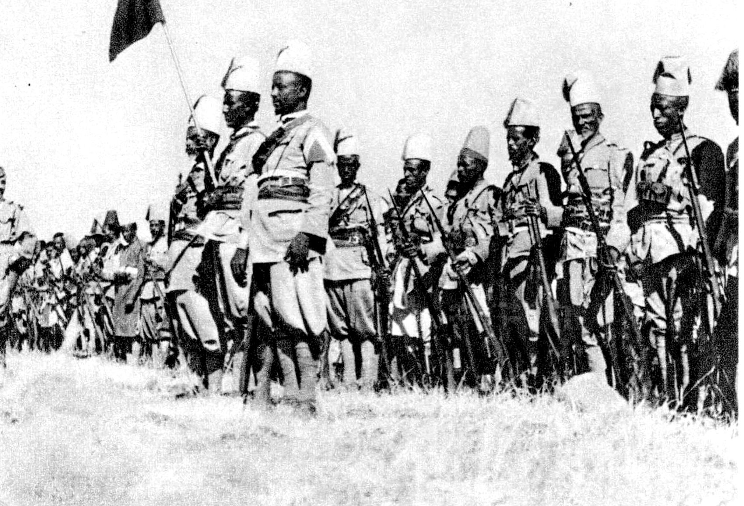

Why did Mussolini not just seize Abyssinia?

Despite Mussolini’s disdain for the League of Nations, he could not overlook the fact that the two most powerful states were also guarantors of Austrian independence. Britain and France dominated the entire Mediterranean and Red Sea region by virtue of their territorial possessions, naval and air bases, joint ownership of the Suez Canal and crushing aero-naval superiority. Such overwhelming strength on the part of Italy’s former allies, more than matched by their vast imperial possessions and superior financial and material resources, meant that both had to be kept firmly onside. There were huge reservations amongst the Italian high command as to whether victory would be possible. The Abyssinian army was four times larger than it had been when they had defeated the Italian’s at Adowa and their officer corps were French trained. To defeat an army of 500,000 would be difficult given the very poor rail and road infrastructure, which had doomed the invasion of 1896. The entire colonial war would require around nine milliard lire, equal to roughly a third of Italy’s gold reserve, a figure which Italy’s already fragile national economy would find hard to sustain. The Italian navy remained vulnerable and was not capable of protecting the amount of shipping, needed to equip the army. If Britain closed the Suez Canal or instituted a stop and search policy, then the Italian navy could not resist. Therefore, the Italian leadership demanded that Italy have approval from Britain and France for any invasion, lest actions taken to derail the operation proves successful.

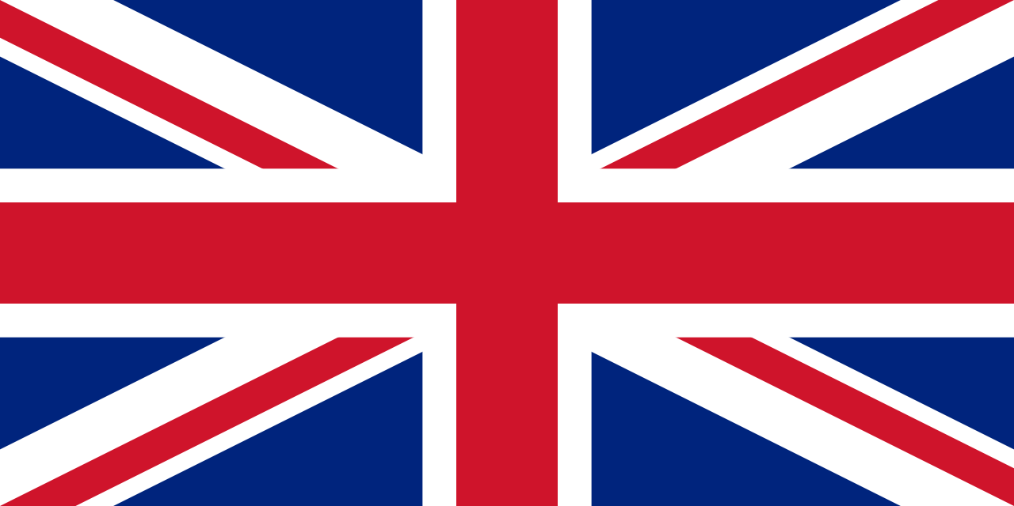
What was the British Reaction?

- Piers Brandon describes British foreign policy at this time as the “most flagrant practitioners of realpolitik at the time clinging to a fig leaf of morality.” Mussolini was relatively popular with conservatives in Britain. The consensus was that he had modernised Italy and could be a useful ally against Hitler. The British ambassador to Italy, Sir Eric Drummond, supported fascism and believed Italian assertions they were victims of oppression. Mussolini’s miscalculation was in presuming that the British government could give away the sovereignty of a member of the League of Nations and maintain domestic support. Around 90 percent of the 11.5 million voters in the League of Nations Union Peace Ballot in 1935 voted for British membership and of the use of sanctions to halt aggression. In the light of such pro-League opinion in a year where an election was due, British politicians and government officials would have to be seen to support sanctions. While the majority of Britain’s political class favoured good relations with Italy, this did not extend to the annexation of Abyssinia, which they viewed as strategically important. Abyssinia was the source of the Nile, which provided the water needed in the Sudan and Egypt and would also allow Italy to potentially dominate the shipping lane to India.

- In the face of British resistance Mussolini emerged totally defiant. With Nazi and Japanese militancy beginning to make their presence felt, he knew that the British Empire could not engage with two foes in separate theatres simultaneously. This sense of self-belief and assertiveness was in evidence as Foreign Office officials in London panicked over what to do with Fascist Italy’. Despite obvious signs, Britain was also thrown by the February 1935 announcement that Hitler had reintroduced conscription and was building an air force. Both Britain and France met outside the League of Nations with Italy, which Mussolini was now consciously attempting to sideline. Whilst the meeting was designed to respond to Germany, Mussolini’s primary aim was to gain approval for the Abyssinian expedition. Something that Britain had failed to realise, while Laval presumed would be shelved given the deteriorating situation in Europe. The conference at Stresa ended acrimoniously with the British vowing to turn any invasion of Abyssinia over to the League of Nations and the French cautioning the Italians against it.

- Britain made its first move to negotiate outside the League of Nations in June. In doing so it completely abandoned its later claims to stand behind collective security. Bartering with Italy was even more foolhardy in that it was proposing to hand over the arid Ogaden region and Wal Wal to Italy, while compensating Abyssinia with its own port of Zeila. An action unlikely to be accepted by either the Italian’s, Abyssinians, or the House of Commons. Not surprisingly, Mussolini rejected the deal completely. He had now invested too much of his own prestige and finances into the expedition for him to call it off. He could not allow Abyssinia access to the sea under Britain’s protection. At the same time, Mussolini received a copy of the supposedly secret Maffey Report. Here the British government decided that the lack of strategic interests in Abyssinia meant they would not oppose an Italian invasion with force. Likewise, Abyssinia had no interest in accepting the deal as they were under the impression that Britain would support them under all circumstances. After these talks failed Britain, banned weapons sales to either Abyssinia or Italy (which was of more benefit to Italy than Abyssinia) and removed its Navy from the Mediterranean, giving Italy easy access to the Red Sea.

- Britain faced a strategic dilemma in confronting Mussolini, even if it was politically expedient to do so. In July, Britain signed the Anglo-German Naval Agreement, signaling their defense capabilities were over stretched. That Britain had signed a deal with Germany, when they were flouting the Treaty of Versailles and international order, only encouraged Italy to do the same thing. Despite the inconsistencies of their policy, Britain continued to pursue a policy of referring the Abyssinian matter to the League of Nations, when the only likely outcome was to push Germany and Italy to resolve their differences over Austria. What Britain had failed to realise was that the Italian preparations had been plagued by problems and was months behind schedule. There was almost no confidence in the High Command that a quick victory was possible and any actions taken by Britain or the League could have prevented the success of the operation.

- The failure of the Stresa Front gave Hitler an opportunity to act. Nazi officials courted and flattered Mussolini, all it took were frequently repeated assurances that Nazism had no intention of reaching a forceful resolution to the Austrian question, and Mussolini started listening with interest. Meanwhile, relations with Britain continued to deteriorate, with Britain not willing to backdown, but also not offering any stronger resistance than proposing mediation between the two countries. Mussolini remembered Britain’s failure to uphold the principles of the Geneva Assembly during the Manchurian Crisis and resented what he viewed as their double standards then and now. For him the League remained a flawed organisation serving the interests of its more powerful members. He also felt Britain was hardly in any position to dictate terms to anyone when it came to colonial expansion. In May, Mussolini ordered up the drawing up of plans for a potential war with Britain.

- Britain overestimated the Italian Navy’s strength. It worried about an attack on one of its two major Mediterranean bases in Malta or Gibraltar. In August, the Italian financial situation deteriorated as foreign investments reduced from 313 million lire to 11 million. The regime presented this as sanctions, but in reality, the majority withdrew over fears the economy would collapse as it embarked on a war it could not afford. If the League of Nations imposed tough sanctions then there was no way that the Italy could continue its war. Despite Mussolini threatening any sanctions as an act of war, there was no possibility that Italy would declare war on Britain. The Italian airforce was incapable of undertaking any raids on British bases outside of Malta and the Italian navy had no aircraft carriers (Britain had six) and was deficient to the British Mediterranean squadron in every respect. What was clear is that both sides were now blustering, with neither having any intention on following through with their threats, but only Mussolini was determined (or reckless) enough to continue with the bluster. But the net result of this was Mussolini was losing support in France, the more that Mussolini continued with his intransigence and venomous remarks against the British, the harder it was for the French to continue to pursue with their support of the invasion and on 21 August, Laval informed the Italians that he may have to support Britain, as long as sanctions remained off the table.

- In September 1935, Samuel Hoare condemned Italian actions. But by extolling collective security and the League of Nations they removed British responsibility; they could have closed the Suez Canal but opt not to. Later that month the British Parliament voted to support a bill proposed by the Labour opposition to impose economic sanctions on Italy if they continue their aggression. Anthony Eden continued to signal to Italy that Britain would impose sanctions should Italy invade, which resulted in a groundswell of public support.

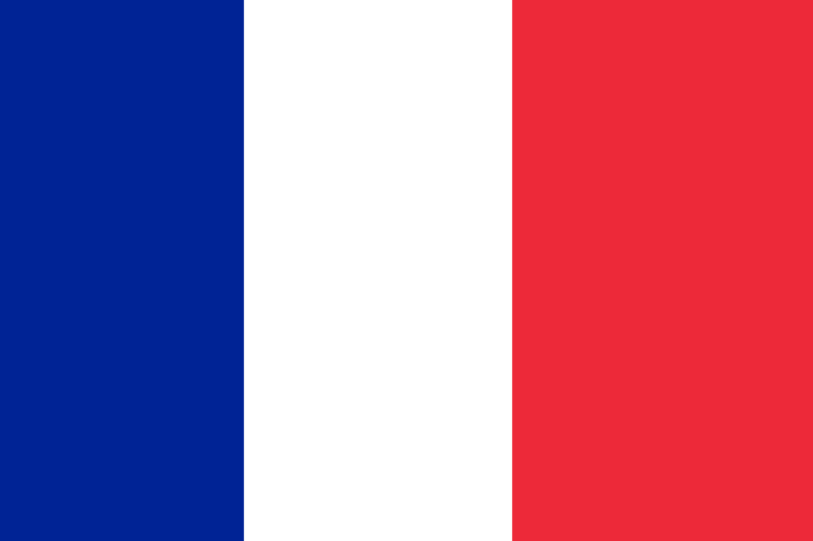
What were the French Reactions?

- The Nazis 1933 seizure of power and their disavowal of Versailles encouraged Mussolini as it appeared that the British and French hegemony was weakening. As Hitler secretly re-armed Germany, the Italian Fascists became potentially indispensable friends of France. The war scares and press hostilities of the 1920s and early 1930s were forgotten as the two countries realigned themselves. The French Prime Minister, Barthou, informed Mussolini that an agreement with France over the future of Ethiopia was possible but would certainly not be easily reached. Much would depend on the extent to which Mussolini supported French diplomatic initiatives and continued to defend Austrian independence. An issue at the heart of French anti-Hitler thinking. Mussolini then made an inflammatory speech where he praised the culture and achievements of the Mediterranean people as being superior to those of Northern Europe. Mussolini refused to move his position on Austria, even as the Germans claimed they had no further desire to become involved in Austrian affairs, Italy continued to lie to the Germans and deny that they had any plans to annex Abyssinia.

- Despite these issues, the French continued to push for an alliance with Italy. Even the assassination of the Yugoslavian King and Barthou in October 1934, by a Croatian separatist with strong ties to Italy was not enough to slow the moves toward an alliance with Italy. The new French foreign minister, Pierre Laval (who did not know where Abyssinia was or that it was even a member of the League), covered up any notion of Italian involvement, shifting the blame to Hungarians. Mussolini invited him to Rome in January 1935 to formalize the alliance. The discussions more or less focused on vital areas of European policy such as Austria, Nazi rearmament and the need for improved Italo–Yugoslav relations. Only at the very end of the final meeting did Mussolini mention Abyssinia, obtaining from Laval a clear confirmation that he fully understood what Italian aims were, and that ‘his country did not intend to hamper Italy’s policy of penetration into Abyssinia’. The agreement immediately benefitted both countries as they could reduce the forces along their borders to allow France to concentrate on Germany and Italy on the build-up in Abyssinia.

- But France, were at a diplomatic impasse as Britain was unenthusiastic for allowing the Abyssinia’s annexation, but at the same time were providing minimal support to prevent the Anschluss. France had to weigh up who would be more useful in a war with Germany. While Italy provided better short-term solutions in potentially guaranteeing the borders of France’s eastern allies, in the long term any war with Germany would need British support. On the 20th May, the British and Italian foreign ministers met and the Italian’s informed them that the invasion would continue even if Britain and the League of Nations objected. With conflict looking likely, Laval now moved back towards Britain, lying to the British that he had ever agreed to give Italy a free hand in Europe while at the same time making overtures to Italy saying that he would try and get the British to back down. At the meeting of the League of Nations, both sides agreed to a French suggested vaguely worded investigatory committee, which Mussolini should have taken as a victory as it gave him five uncontested months to prepare. But the positive reaction by the British public, made it appear a defeat to his plans and he further resolved to not be seen to back down again.

- By July, Mussolini was nervous, choosing to believe reports that Britain was planning on accepting Abyssinia as an Italian mandate, which caused him to send a warning that any type of opposition would be seen as a declaration of war. Supporters of the League in Britain made calls to right the injustices of Manchuria through concerted action and publicly considered forming volunteer regiments to resist the Italian invasion. With preparations for the Ethiopian campaign far from complete, the last thing Mussolini needed was the possibility of concerted League action. The dictator had nothing to fear. The French government were determined to meet commitments that stemmed from the Mussolini–Laval Accords and that summer Badoglio and his French counterpart, General Maurice Gamelin, concluded a military agreement that bound France and Italy together in any war against Hitler’s Germany. The French, unable to secure any serious support against Nazism from the British, who had betrayed them in negotiating with Hitler, needed their new Italian allies and clearly had no intention of joining League action against them. Eager to see the crisis between Britain and Fascism resolved, Laval agreed to a proposal by Hoare that the three countries should meet as co-signatories of the 1906 Triple Agreement and seek finally to resolve the current impasse.

What was Britain’s (contradictory) position on Abyssinia?
What was France’s position on Abyssinia?

How did Britain encourage Italian aggression?
What actions did France take in encouraging Italy?

Who was most to blame for the continued escalation of the conflict.

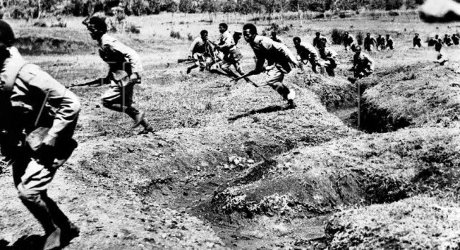

What did the League Do?

- In September, a five power commission of the League proposes a solution but Abyssinia rejects the proposal.

- In October 1935, the Italian invasion begins, and the progress is less than spectacular. The Abyssinians were armed with outdated weapons, with some units preferring to fight with spears and swords rather than firearms. They valued bravery over tactics, which made them difficult to co-ordinate, so much so that Hallie Sellaise ceased to try. Despite Abyssinian problems, the well-equipped and mechanized Italian army, struggled to make progress – largely due to the commander De Bono’s cautiousness. He preferred to save Italian lives by attacking the Abyssinians from a distance.

- Aerial bombing by the Italians and the use of poison gas over large areas led to the deaths of 250,000 civilians as well as killing livestock, poisoning water and destroying crops. Haile Selassie, escaped to Britain while practically all organized opposition to the Italian occupation collapsed in the midst of the destruction in early 1936. Guerrilla attacks, however, continued, leading to Mussolini himself ordering prisoners to be shot, that various villages be gassed where resistance had been discovered, and that priests and others suspected of complicity in armed resistance be executed.

- The scale and brutality of the Italian invasion meant the League would have to see through on their threats. Limited economic sanctions were imposed; they included, as Lloyd George said, “elaborate arrangements to deprive Italy of those things she could do without.” The League banned the import of mules and camels, for example, but not cars and lorries. Britain decides not to close the Suez Crisis, they declare it to be a matter for the League to try and remove their responsibility. Conservatives in France supported Mussolini’s actions.

- The economic sanctions took six weeks to organise. Oil was not included for the argument it could simply be bought from the USA. Britain would not stop exports of coal for fear of unemployment in already economically deprived areas. Despite the timid response, it played right into Mussolini’s hands and he used it for all it was worth. He portrayed himself as a national champion against the machinations of the other powers who wanted to hold back Italy. Despite being able to get all essentials from the Soviet Union, he brought in wartime measures that were scarcely necessary, he ordered offices to shut early in order to save fuel, banned the sale of meat on two days a week and even promoted the breeding of rabbits.

- In November an oil embargo is proposed, Mussolini stated this would be seen as an act of war. Britain wished to push for further sanctions, but France conspicuously refused to support Britain on the issue. Britain waited to see the results of a Papal legation that was attempting to convince Mussolini to take the gains he had already made in return for ending any further invasions. The French presented Mussolini with their own plan, which gave Italy the majority of Abyssinia under the nominal control of the League of Nations, while giving Abyssinia the port of Assab. France made it clear that Djibouti which was under their control should be the preeminent port in the area as they owned the railway line from their to Addis Ababa – the British were aware of the plan and made it clear to France that this should not be leaked to the public before the British election on 14 November.

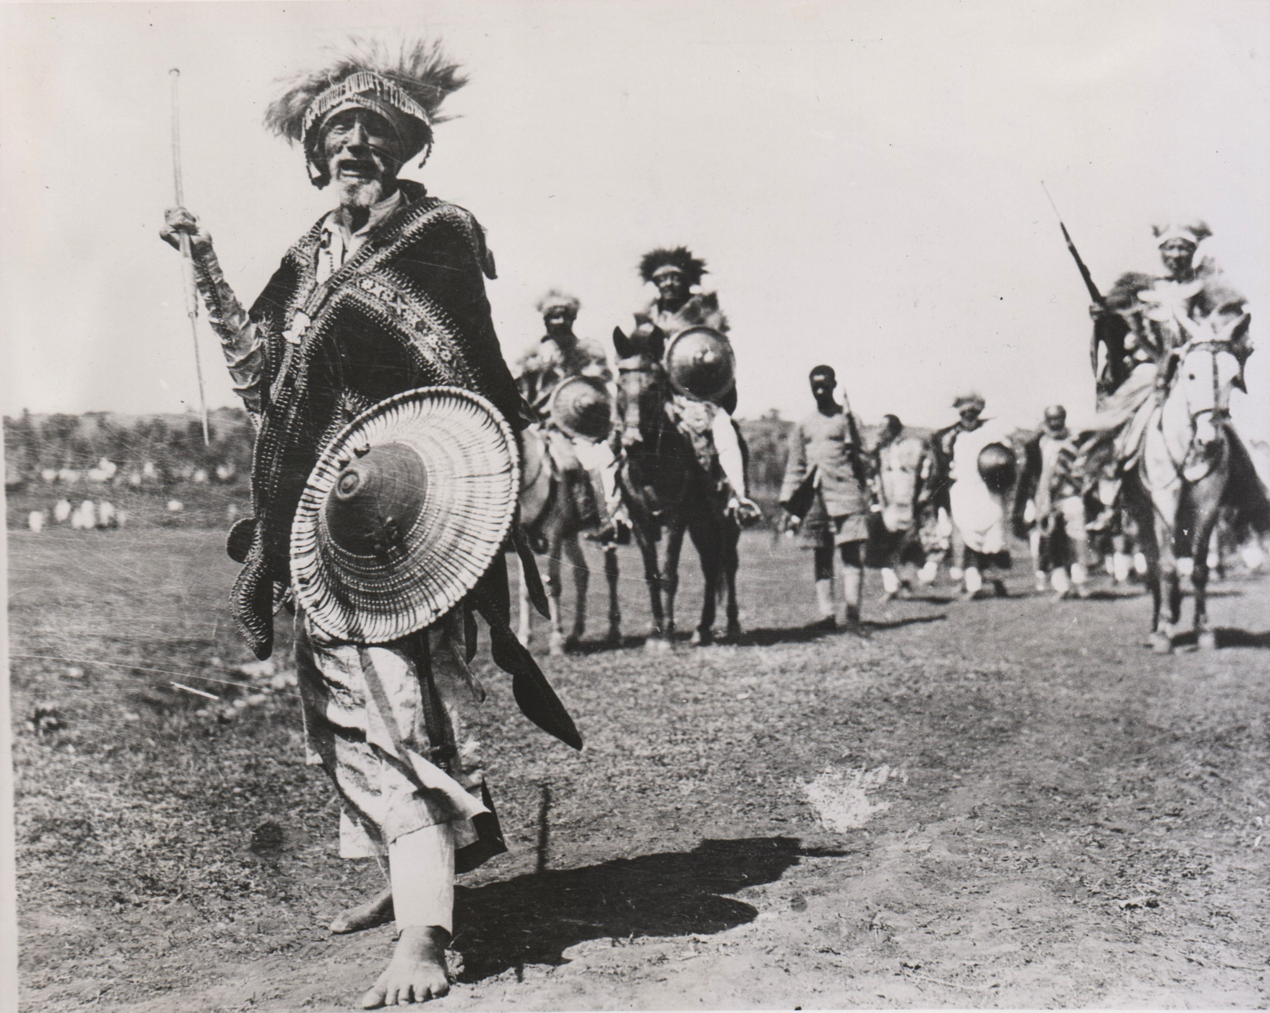
The Hoare-Laval Pact
- In December 1935, Britain and France, met to deal with Italy, despite the British Foreign Minister – Samuel Hoare promising he would do no such thing in the election campaign a month earlier (he also outright lied when French negotiations were leaked to the press and Hoare denied having known anything about them). The meeting was secretive, with Hoare nominally leaving Britain for a holiday in Switzerland and to stop and meet Laval on the way. It was scheduled for 7 December, with the League to meet to discuss oil sanctions three days later (a meeting which Britain had delayed from November). The end result of the talks was nothing short than madness. When Hoare arrived in Paris, he was immediately made aware that France would not support any oil sanctions against Italy and he therefore tried to limit the extent of territory that was given to Italy. In the end he utterly failed and the agreement was:
* Italy would get 2/3 of Abyssinia. Which included the major provinces of Adowa, Adigrat, Ogaden and Makele. This was almost identical to the Italian ambassadors suggestion.
* It was not clear if Abyssinia had to disband its military or had the rights to send its military into Abyssinia, both of which were Italian demands.
* Italy was responsible for the welfare of British protected Somali tribes in the south.
* Abyssinia should have access to the sea, but it was not clear if it should be the port of Assab in Italian Eritrea or Zeila in British Somaliland. In either case it did not really matter as France forbid the Abyssinians to build a railway to their port.
* If Italy did not accept this proposal, then France would agree to recommend oil sanctions.
* The proposal would be given to Ethiopia on the 11 December, so they knew if they did not accept then Britain and France would not support the oil sanctions.
- When the proposals were put to the British government cabinet on 9 December, unsurprisingly there was little support. It was opposed for three reasons:
- It was rewarding aggression and would therefore be resented by the League of Nations.
- Italy was receiving too much territory.
- It was less than what Mussolini had demanded in June so there was no way he would ever accept it.
Despite this the British Government decides to proceed with the plan!
- . There is public outcry on 10 December when it is leaked to the press in both France and Britain. The Prime Minister, Stanley Baldwin, lied that he had not given Hoare authorisation to do anything. But it was he who sent Hoare to Paris and demoted the deputy Foreign Minister Anthony Eden when he continued to push for oil sanctions. There is a perception that the public outcry meant that the plan was shelved, but that is not true. Anthony Eden was sent to the League in Geneva on 12 December to call for a delay to any proposed oil sanctions, despite Britain only having support from Australia. Canada, New Zealand, and South Africa moved against Britain to join the now sizeable coalition of Greece, Poland, Netherlands, Yugoslavia, Finland and the Soviet Union against the plan. It is also important to remember that Mussolini had now been presented the plan by Britain and he had not even agreed to it.

- What finally sunk the plan, was the full text being published in a French newspaper stating that Abyssinia would not even be allowed to build a railway. It was now obvious that this settlement was unfir to Abyssinia. Even though Britain had the term removed, it was now too late, and the British cabinet began to move to disavow the speech.

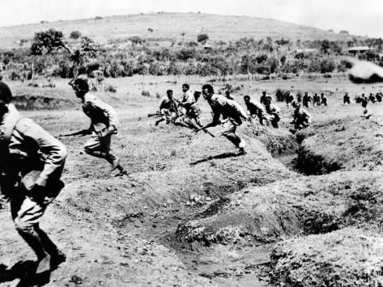
- Somewhat comically Hoare continued onto Switzerland for his planned holiday and had broken his leg skating. He was therefore unable to return to London. In his place it had been decided that Neville Chamberlain would read his speech. He admitted that Britain could no longer support the Hoare-Laval settlement, but emphasized a desire to avoid a general European or an Anglo-Italian war. Either event would result from the oil sanction, and French assistance against an Italian attack was doubtful. The risk involved was too great. A diplomatic solution was essential, the Hoare-Laval plan being the minimum Italian position.

- This was too much for the British cabinet, who felt that it would cause them to lose their narrow majority and could trigger another election. Thirteen refused to allow the speech to be read, with most calling for Hoare’s resignation. Baldwin supported Hoare, but he chose Neville Chamberlain to tell Hoare that cabinet would not support his plan. Baldwin did not want Hoare to resign, but he did anyway. When the House of Common’s met on 18 December, there was almost unanimous hostility to the government’s actions, from both the Labour opposition and amongst the Conservative’s backbenchers.

- On February 26 the League announced the imposition of Oil Sanctions, but by now it is far too late. The USA also has to take some blame for this. In 1934 the USA supplied 7.0% of Italian oil and British owned companies was 10% (the majority came from Romania and the Soviet Union). In September 1935, the US percentage had risen to 21%. Clearly it took advantage of the situation to boost its own share of the Italian market. The neutrality act meant that it was illegal for US companies to supply either side in a war, but President Roosevelt did not have the congressional support to declare oil an instrument of war. He tried to convince US companies to put a voluntary embargo on Italy, but they did not. Romania and the Soviet Union pushed for sanctions prior to December, which would have crippled the Italian war effort. The revelation of the Hoare-Laval plan meant that both nations dramatically increased their exports to Italy, meaning that by the time the sanctions were in place, Italy already had sufficient reserves to complete the invasion.

Was it ineffective sanctions or the Hoare Laval Pact that meant the League failed in Abyssinia?

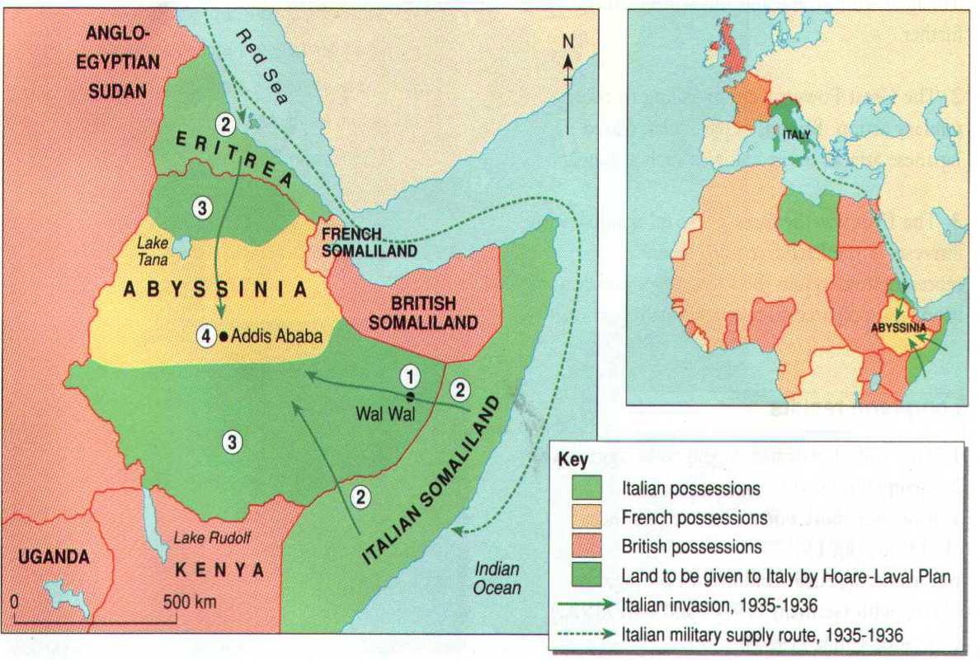

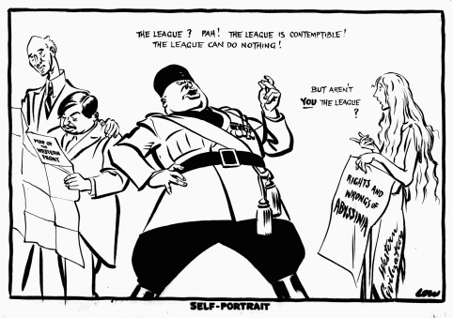

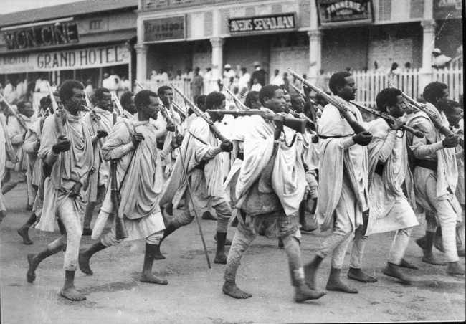
What Does this Mean?

- In March 1936, the Battle of Mai Ceu, meant the war was effectively over. It was hardly a sparkling triumph for the Italians, with victory caused by 170 Italian planes carpet bombing the defenders. In May 1936, Italian conquest complete with the conquest of Addis Ababa and Victor Emmanuel becomes King. Hailee Selassie was forced to flee to England, where he had to be hidden to ensure he did not gain a triumphal reception.

- In June 1936, Haile Selassie addressed Assembly of League calling for help to recapture his throne. This was a complete farce with Italian journalists howling and whistling at him as he tried to speak. The lights were then turned off to try and stop the disturbance and the Romanian foreign minister shouted to “throw out the savages.” The League is no longer in existence. Selassie states “It is us today. It will be you tomorrow.” No additional action by League. After this final chapter, most agreed that the League was now dead. The French President Leon Blum stated:
The League of Nations no longer condemns the Fascist acts of aggression; the League “notes,” the League “does thus and thus,” the League “deplores”—the League makes a hypocritical show of balancing between the criminal and his victim . . . Even more intolerable are the lies concealed in these formulae, and what can be read between the lines: the League’s confession of impotence, its abject surrender, its acceptance of the fait accompli.
The great Historian Arnold Toynbee blamed the fiasco on the cowardly and mealy-mouthed politicians of Britain and France who made no attempt to use collective security in the face of naked aggression. It is an interesting question to say who should take the most blame, France who was utterly disinterested in Abyssinia, preferring to sacrifice the country for European stability or Britain who half-heartedly tried to solve the crisis through diplomacy when also signaling that they would do exactly the same thing. Whilst, French support was never particularly strong, they at most would have abstained from any British action. It would have been entirely possible for Britain, Greece and Yugoslavia to take military action against Italy.

- The Hoare-Laval plan showed that Britain and France would act in their own self-interests even if it meant that a weaker country was a victim of aggression. For Mussolini the abortive plan was a glittering triumph. Hoare and Laval had divided and discredited the European democracies. They had undermined the League and the policy of collective security. They had legitimised Fascist aggression by seeking to reward it.”

- It was shown that the League’s major sponsors and leaders were only willing to use it as a tool of their own foreign policy, jettisoning key sections of the League’s Covenant at will. The Covenant was the very thing which gave the League any meaning and a reason to exist. Economic sanctions were shown to have no effect on the Italian economy. They were enough to alienate Mussolini without seriously hampering his war effort.

- It was not just a blow to the League of Nations, but seriously damaged the idea of colonialism throughout the world which inadvertently effected Britain and France. The notion of colonialism had always been built on white superiority and the need to bring ‘civilization’ to lesser people. The actions of the Italians shattered this belief, the horrific reports of Italian planes dropping poison gas not only on soldiers, but also civilians rightfully outraged many.

- Italy and Germany finally put aside their differences. This was signaled on the night before the invasion when Mussolini said to the German ambassador that Britain had shown itself to be an opponent of Fascism and this should be of concern to Germany too. Italy left the Stresa Front, moved towards Nazi Germany, signing the Rome-Berlin Axis in 1936. Hitler noted the weakness of the League and remilitarized the Rhineland in March 1936. This was forbidden under the Treaty of Versailles and the Locarno Pact. Italy told Britain and France that they would only take action if the sanctions were lifted. In any case Britain herself was powerless. In preparation for the oil sanction, the reinforced Mediterranean fleet had been on a virtual war footing since September, while the home air and military reserves had been denuded to strengthen the forces in Egypt. In such circumstances, the service Ministers held, Britain could not possibly fight Germany.

- It was a massive boost to the support of Mussolini. On the eve of the invasion 20 million had turned out in demonstrations of support across the country, but foreign observers were unconvinced on whether there was much enthusiasm amongst the Italians. This was certainly not true after the conquest, peasants knelt in the fields as he passed, held their children up for him to bless, pasted his picture on their cottage walls beside that of the Virgin Mary. Victor Emmanuel, who now considered Mussolini a military, as well as a political, genius, made him a Knight of the Order of Savoy; the Duce in turn poured out lesser decorations, fostering his cult in the armed forces. Mussolini had turned a squalid colonial adventure into a great patriotic crusade. He had transcended the Depression and transformed domestic anguish into foreign aggression. He had become the embodiment of Italian passions and aspirations. He had completed his identification with Augustus, which was not only celebrated in art, architecture and books but in the great exhibition staged in 1937–8 to mark the bi-millennium of the Emperor’s birth. Both the King and the Pope who had deep misgivings about the invasion now quickly fell into full-bodied support for Mussolini. It was clear that his hold over Italy had never been so complete, but it did give him delusions of power, which made him over-confident in confronting better adversaries.

- Italy kept Abyssinia, even though the Abyssinians finally began guerrilla warfare. In order to counter this guerrilla war the Italians set up concentration camps and conducted mass executions of potential Abyssinian leaders including priests and schoolteachers. The guerrilla campaign cost Italy 12 billion lira and only 3,500 Italians ever settled there It was eventually liberated by Britain in 1941 after Italy had declared war the previous year.

- Britain and France realised that the League was not capable of solving major disputes and were now prepared to put aside the economic misgivings to begin rearmament. Collective Security was dead.

It was Abyssinia that ended the League as an effective Peace-Making Body.

Opposing Forces of the Italian and Abyssinian Armies

 | Italy | Abyssinia
Soldiers | 685,000 | 500,000 est
Rifles | Unknown | 400,000 (most pre 1900)
Artillery | 2000 | 200 (Antiquated)
Aircraft | 595 | 13 (4 pilots)
Tanks | 780 | 3 (WWI)
Machine Guns | 6000 | 50
Total Casualties | 10,000 (9,555 1936-1940) | 275,000

