______________________________The Cuban Missile Crisis________________________________
Why was Cuba so important to Kennedy and why could he not tolerate the installation of Soviet Missiles? https://www.bbc.co.uk/education/guides/zygjq6f/revision/5
What do we know about Cuba?

Problems with Berlin
Khrushchev got the better of Kennedy at their Vienna in May 1961, he berated him for two straight days, which left Kennedy exhausted and feeling out of his depth. Kennedy begged Khrushchev not to issue another ultimatum but got one anyway. Khrushchev then further embarrassed him by promising to keep it secret, then announced it anyway after Kennedy had already announced to the public that there were no ultimatums. Kennedy was furious with Khrushchev calling him a “fucking liar” and “an immoral gangster...not a statesman, not a person with a sense of responsibility.”
Khrushchev almost immediately regretted his decision, privately he mused that Kennedy was so weak that he could be bossed around by hawks in his cabinet. Kennedy was not going to back down and secured $350 million to pay for his flexible response. In August 1961, the Soviets began building a wall to prevent the exodus to West Berlin. Khrushchev was worried the USA would try to dismantle it, but aside from a nervous few hours where they tested their access rights and General Lucius Clay moved his tanks towards the wall Kennedy did nothing. As he said to his brother Robert “A wall is a hell of a lot better than a wall”. Kennedy became convinced that the Soviets only respected those who were as tough as them and if they allowed them to intimidate them in Cuba then they would use nuclear blackmail to remove the US presence from Berlin.

Political Reasons
Kennedy had attacked Eisenhower over the lack of action on Cuba; aside from the Bay of Pigs progress was slow. The CIA was openly hostile and Operation Mongoose was proving to be a bust. He was coming under increasing attack with from Republicans with the moderate Keating claiming that Nuclear Weapons were already installed on the islands. He had received assurances from Dobrynin in early September that no offensive weapons would be installed in Cuba and on 13 September he publicly announced that the US would not tolerate nuclear weapons in Cuba. It was wrongly presumed, thanks to Soviet Propaganda that the Soviet Union already had enough nuclear weapons to hit the USA, so placing more on Cuba would be an aggressive action. If it was discovered that Kennedy was taking no action and was willing to be lied to then it would be a disaster for the Democrats in the November mid-term elections and could sink Kennedy’s chances for reelection in 1964.

Reasons why Khrushchev Put Missiles on Cuba
- Khrushchev was ecstatic, that he had been able to construct his wall and solve the German problem, oblivious to the negative image it presented on the nature of Communism and the fact he had failed to achieve his basic aim. Crucially it encouraged him to test Kennedy again, this time in Cuba.
- Khrushchev genuinely believed that the Americans would stage an attack on the Guantanamo naval base and use it as a pretext to an invasion. Kennedy had reportedly told Alexei Adzhuebi that America should have liquidated Castro like the Soviets had done to the opposition in Hungary (he hadn’t, but Khrushchev believed that he had). He saw the large-scale training drills (40,000 men in a practice invasion in April), knew the CIA was planning to remove Castro and drew the conclusion that an invasion was imminent. Khrushchev most definitely had a strong personal interest in protecting the Cuban Revolution.
- The Chinese had criticized Khrushchev for capitulating to Capitalism; Castro had fallen out with the pro-Soviet leader Escalante and Khrushchev was worried that Castro would come under Mao’s control. Che Guevera certainly wanted to follow the Chinese advice to spread revolution to the rest of Latin America.
- Khrushchev remembered Stalin’s warning that the imperialists would strangle the revolutions successors like Kittens. His recollections of the crisis said “I sought to destroy capitalism and create a new world social system based on the teachings of Marx, Engels, and Lenin.”
- There was little opposition to Khrushchev’s plan in the Kremlin.
- His own position in the Soviet Union was far from secure, economic growth was sluggish, intellectuals were hostile and his extensive show piece of irrigating the plains of Kazakhstan was turning into a disaster. He was worried that if he failed to protect the Cuban Revolution then it could be a pretext for his rivals to move against him.
- In October 1961, the Soviets tested a 50-megaton weapon that was as powerful as all the weapons used in the Second World War put together. However the US knew that the Soviets did not have the ICBM sites to deliver the weapon load. America also announced that it had developed a second strike capability through its Polaris submarines, that was greater than the Soviets first strike. Khrushchev was terrified that the US would find out just how unreliable his R-16 missiles were. The Russians only had 330 operational warheads that could hit the USA compared to 27,000 that could hit the USSR. The USA could hit the USSR in just a few minutes, it would take half an hour for the Soviet Missiles to reach the continental USA. He simply stated: “Why not throw a hedgehog at Uncle Sam’s pants?”
- By placing MRBM’s on Cuba he could double the number of war heads that were capable of reaching American cities, in a much more inexpensive way than building ICBM sites in Russia. He had already spent $250 million on military equipment for Cuba since the Bay of Pigs, which was simply unsustainable for the Soviet Union. Khrushchev was desperate to cut military spending to fend off growing discontent at home about the poorly performing Soviet economy. He also worried that if he continued to send conventional weapons to Cuba then they would be used to spread revolution throughout the rest of Latin America that would make a reaction by the US more likely.
- Khrushchev underestimated the American reaction, he expected them to take it calmly, as the Soviet Union had done to the Jupiter Missiles in Turkey.
- In 1959, he had visited Bulgaria and had become visibly angry as he relaxed on the beach and viewed Turkey on the horizon. He was heard to remark that he wished to give America a ‘taste of its own medicine”. Khrushchev had badly underestimated the symbolic importance of historic American power in the Western Hemisphere, going back to the Monroe Doctrine. If he wanted to protect Cuba (Khrushchev adored both Cuba and Castro) he could have just installed battlefield missiles or even troops to act as a trip wire. If he got caught before the missiles were functional he would place himself in a very vulnerable position. Castro himself had told him to deploy the weapons openly as legitimate act in the same way the USA had done so in Turkey.
Why did Khrushchev put the Missiles into Cuba?

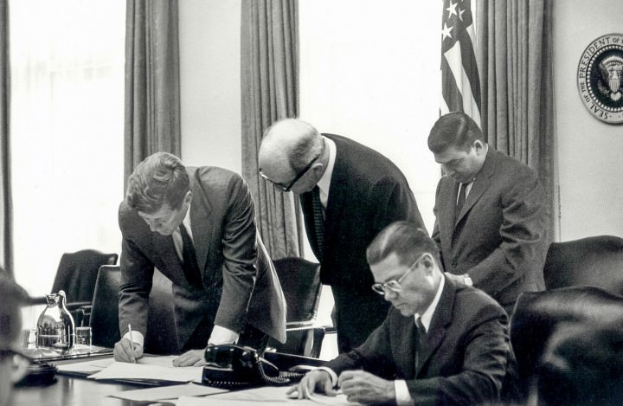
What Options Did Kennedy Have to Deal with the Missiles? (Text Book)
 | Positives | Negatives
Airstrike on the Missile Sites

Full Scale Invasion of Cuba

Negotiate with the USSR

Ignore the missiles

Blockade all ships entering or leaving Cuba

Why did Kennedy decide that a Blockade was the best option to confront Cuba?
http://thebicesterschool.org.uk/wp-content/uploads/2015/09/GCSE-History-Revision.pdf p.22
- ______________________________________________________________________________________________________________________________________________________
- ______________________________________________________________________________________________________________________________________________________
- ______________________________________________________________________________________________________________________________________________________
- ______________________________________________________________________________________________________________________________________________________
- ______________________________________________________________________________________________________________________________________________________
- ______________________________________________________________________________________________________________________________________________________
- ______________________________________________________________________________________________________________________________________________________
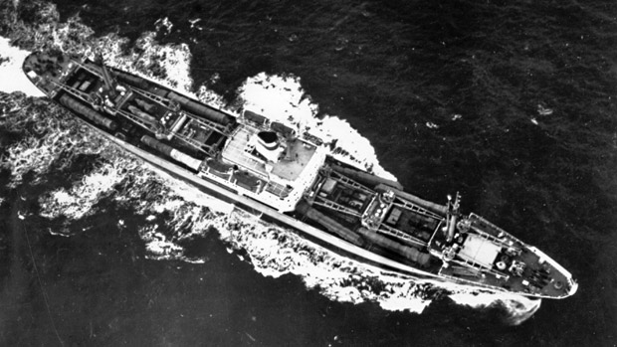
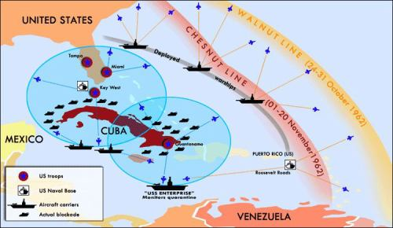

Outline the steps taken to resolve the conflict using http://microsites.jfklibrary.org/cmc/
October 16 ____________________________________________________________________________________________________________________________________________________________________
October 18 ____________________________________________________________________________________________________________________________________________________________________
October 20 ____________________________________________________________________________________________________________________________________________________________________
October 22 ____________________________________________________________________________________________________________________________________________________________________
October 23 ____________________________________________________________________________________________________________________________________________________________________
October 24 ____________________________________________________________________________________________________________________________________________________________________
October 25 ____________________________________________________________________________________________________________________________________________________________________
October 26 ____________________________________________________________________________________________________________________________________________________________________
October 27 ____________________________________________________________________________________________________________________________________________________________________
October 28 ____________________________________________________________________________________________________________________________________________________________________

Who was the victor in the crisis?
Kennedy | Khrushchev

Extra Reading
http://cloudsovercuba.com/
https://www.theatlantic.com/magazine/archive/2013/01/the-real-cuban-missile-crisis/309190/

