_________________________Background to the Spanish Civil War__________________________

Spain was an extremely backward part of Europe; it was geographically isolated from Europe and Africa and was almost untouched by the industrial revolution (wages were so low that handmade products could compete with those mass produced). It was characterized by both regional and class divisions and in many areas feudalism was still prevalent using farming techniques unchanged from the Bronze Age. Its population of 24 million was predominantly rural and their major loyalty was to the land where they had been raised. The majority of the population subsisted on less than US24c a day and was idle for around a third of the year. 10,000 families owned around half the countries land which led to social antagonism. It was presided over by a moribund government, huge bureaucracy and a brutal police force. It was assisted by the Catholic Church, who were so conservative that in some of their schools reading was banned to prevent children learning Marxist literature. The threat of anarchism; which was particularly virulent meant that Spain had lurched between authoritarian right wing governments and the left who made so many concessions that they lost all power.

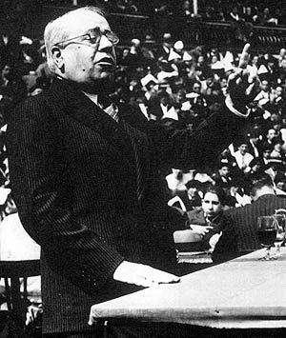

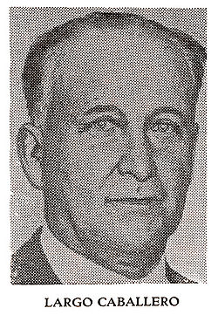

The President Azana had tried to cover up the problems of the depression and bring greater power to the people by taking on the church and King Alfonso. While a gifted public speaker, his attempts to bring about a welfare state did nothing to address rural poverty while angering the elite. He had tried to reform the hideously cumbersome army which took half of Spain’s GNP (it had 800 generals, but only enough ammunition to last 24 hours), by pensioning off 2/3 of the soldiers which created a potentially huge body of dissidents. He also reduced the pay of the director of the Sargasso Academy, Francisco Franco.

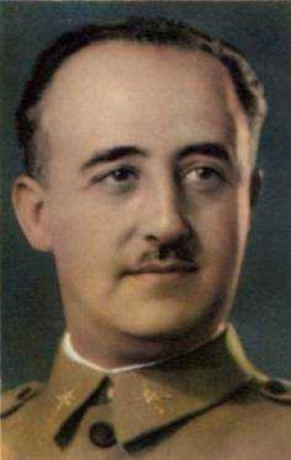

Franco was the most able of the generals and he was also very patriotic and dreamed of regeneration, although his views were nothing like those of Azana. He had performed well with the army in Morocco and his soldiers believed that he could not be killed. Azana had been deposed in 1934 and this saw two years of political chaos. The socialists had united with the communists to seize power assembling a force of 30,000 which was brutally repressed by Franco’s Moroccan army, killing over 2,000 and torturing many more. This repression, caused Caballero to become more radical and while Azana became more popular he was incapable of leading a revolt and abandoning his liberal ideas.

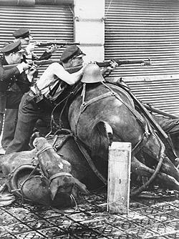

While Azana had reclaimed the presidency (Falangilists and Communists received only 14/470 seats), but he was increasingly powerless. Unemployment had worsened to 20%, and there was no system of unemployment relief. Conflict between Nationalists and Communists worsened, but Spanish democracy was too weak and Azana lacked the will to stop the conflict. Nationalist propaganda increased and on the 12 July, the army murdered Calvo Sotelo an army opponent of the Falangilists). Franco used this as a sign the government was no longer capable of ruling and announced that he would seize power and on 18 July he led an army revolt.

The resulting civil war lasted just under three years. It was marked by the most appalling atrocities on both sides and ended in the deaths (most of them cold-blooded executions) of between half a million to 1 million Spaniards. The brutality of Franco’s troops especially in the siege of Toledo, meant that resolve stiffened in the Republican ranks and they became desperate not to lose control of the area they held. The Republicans however were too ideologically divided and under Caballero became increasingly Stalinist in nature.

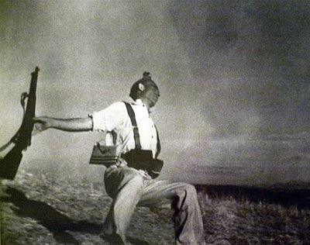

This was not to be the sort of straightforward transfer to dictatorship that had occurred across Europe in the 1920’s and 1930’. The regional nature of Spain meant that many favoured the decreased state power of the Popular Front that was increasingly under the influence of those on the left such as Caballero. So while Franco was able to easily take the South and the West most of the country remained in Republican hands. Azana fled the country and his successor Giral began arming the population, who took their opportunity to attack the church, murdering 700 priests in Barcelona alone. Very soon workers began to collectivize (including prostitutes) and a spontaneous Communist society began to appear. However the forces were untrained, had no leadership, modern equipment, discipline or knowledge of enemy tactics.