__________________Cold War Flashpoints Between Korea and Cuba: The Eisenhower Era________________

In 1951 the Iranians elected the nationalist, but anti-Communist Mohammed Mossadeqh as Prime Minister. His attempts to nationalise Iran’s oilfields resulted in a US and UK boycott of Iranian oil. Mossadeqh then held a referendum on the issue and fixed the results, he also threatened to turn to the Soviet Union for help. In 1953 President Eisenhower used the CIA along with help from MI5 under Kermit Roosevelt and other right wing figures to engineer a coup in Tehran to place the exiled Shah Pahlevi to power. The USA immediately recognised the new government and sent $45 million in aid and advisors to suppress internal unrest.
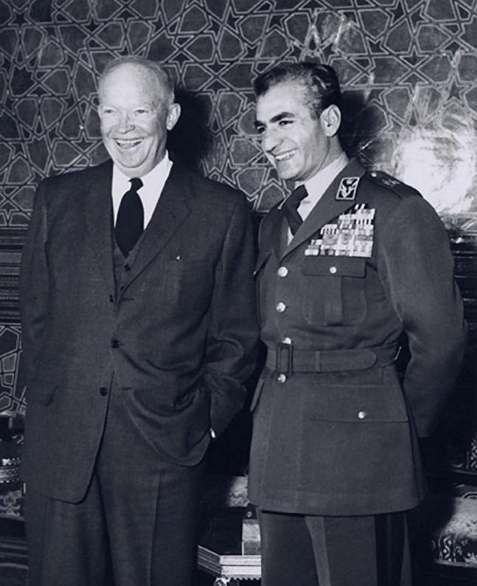

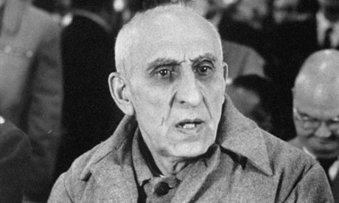

Mohammed Mossadeqh

Eisenhower with the Shah of Iran

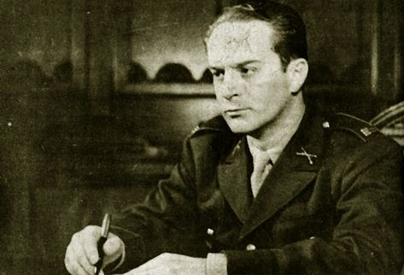
In Guatemala in 1951 a leftist democratically elected government under Jacabo Arbenz Guzman. Guzman attempted to nationalise unused land of the American United Fruit Company. Secretary of State Dulles attempted to use a Czech arms deal to convince other Latin countries to condemn Arbenz, when this failed the CIA again engineered a coup to place the right wing Armas in power. When this stalled, the CIA proposed an air strike funded by US businessmen, Arbenz hearing of US plans fled leaving the repressive Armas to gain power.

Arbenz

In 1954, 50,000 French soldiers were trapped by Leftist Viet Minh freedom fighters at Dien Bien Phu in Vietnam. America was desperate to avoid a humiliation for one of its key NATO allies. John Foster Dulles made it known that he was prepared to lend atomic bombs to the French, which encouraged a ceasefire to be signed and for the French to retain some dignity.
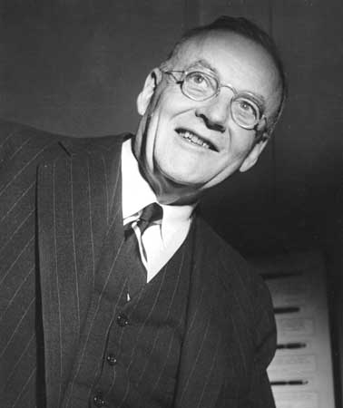
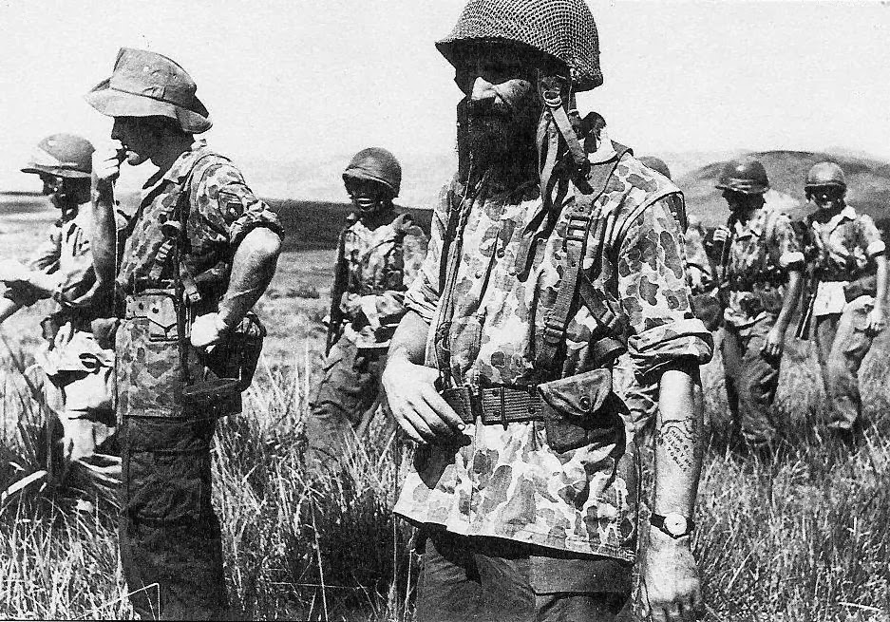

Captured French Soldiers Secretary of State Dulles

In 1954, Mao used his artillery to harass the tiny islands of Quemoy and Matsu, which were still occupied by Nationalist forces of Chiang Kai Shek. Publicly Eisenhower stated that to abandon islands would see Taiwan and eventually all of East Asia fall to Communism – something that was met with horror by US allies. Eisenhower did not actually believe this, but saw it as an opportunity to win a cheap victory and appease the China lobby and those who thought the US was soft on Communism. Eisenhower actively boasted that the US could use atomic weapons to target purely military sites and that an atomic bomb was as easy to fire as a bullet. In response Mao backed down.
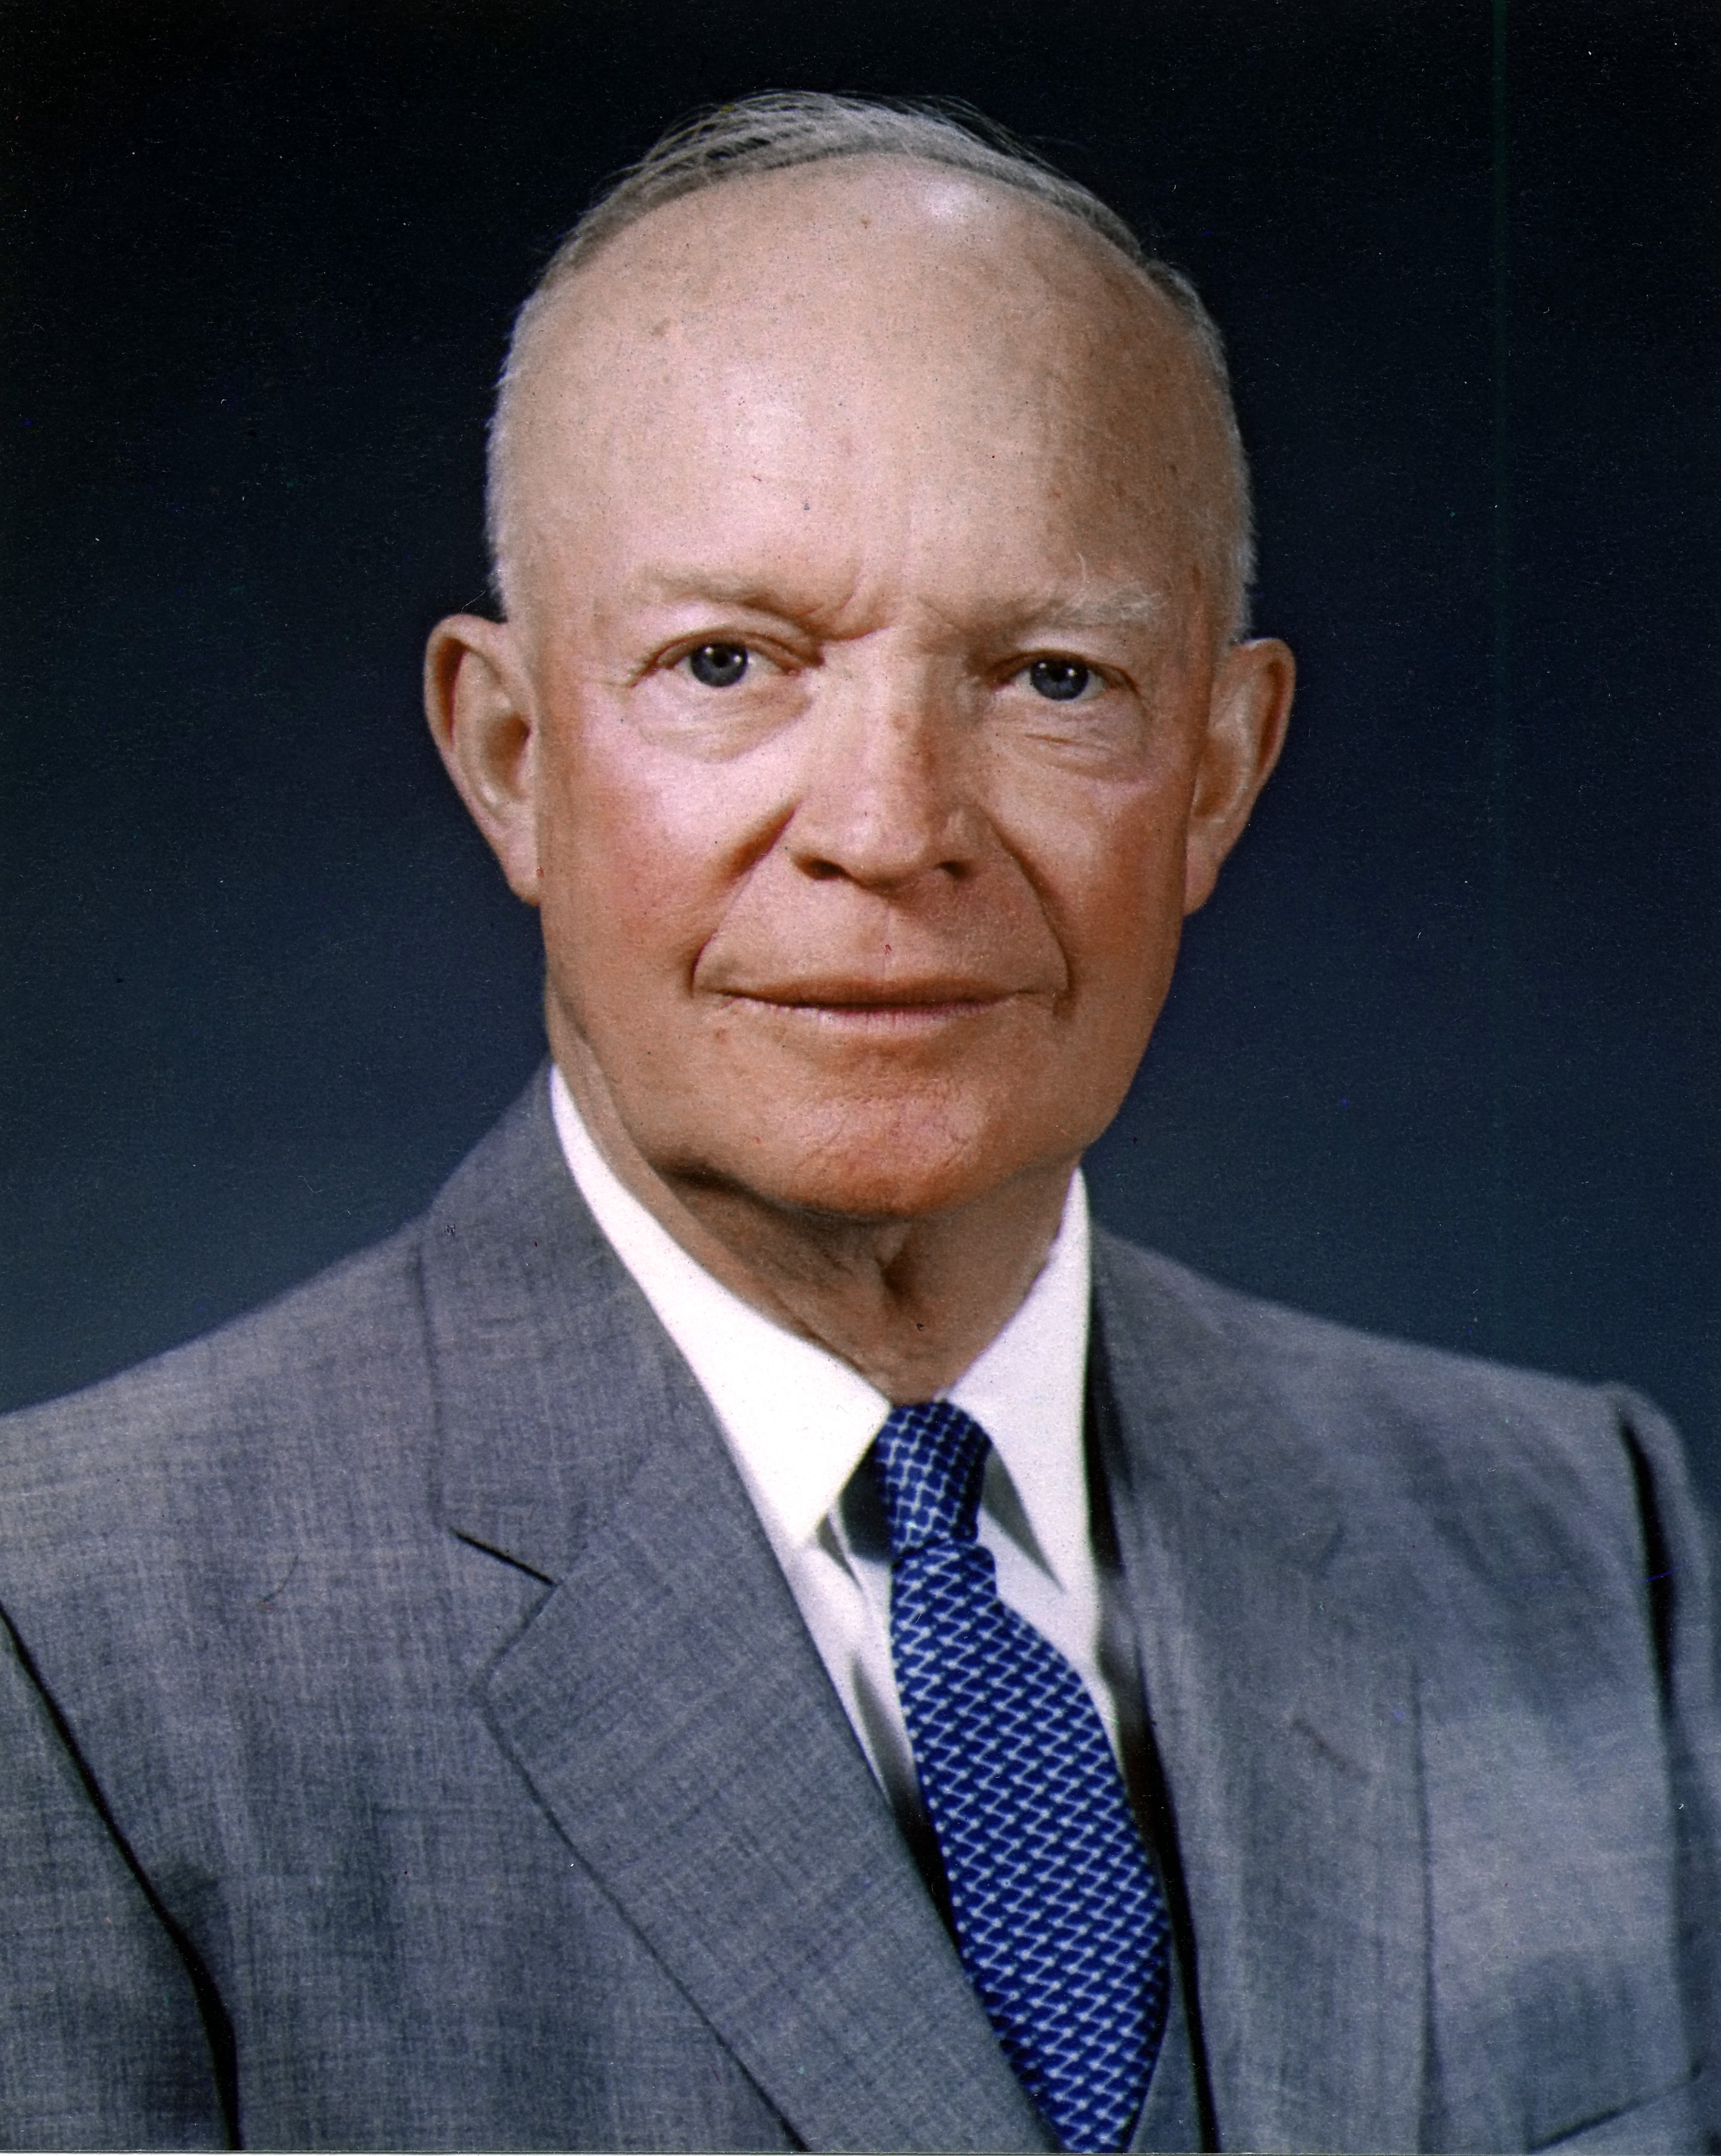
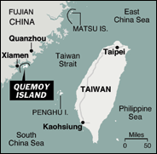

Dwight Eisenhower

In 1956, Abdul Gammer Nassar decided to nationalise the Suez Canal. Britain and France, were outraged having paid to build the canal, which provided a major source of revenue. At Sevres in November, the British and French decided that Israel would invade Egypt and then Britain and France would act as peacekeepers to ensure the security of the canal which would eventually be put under their control. The operation was a military success but a political disaster. The US were enraged that Britian would destabilise the Middle East and potentially leave the area to Soviet influence and launch an operation two days after the Soviet invasion of Hungary. The war placed an intolerable burden on Britain’s Foreign Exchange Reserves and the US blocked any access to an IMF loan. Britian was forced to withdraw and finally lost its status as a great power. Khrushchev believed it was his threats which solved the crisis and Nasser emerged with a strengthened reputation and a new dam for the Nile.
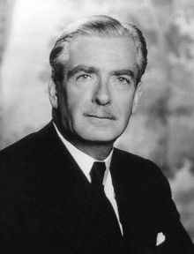
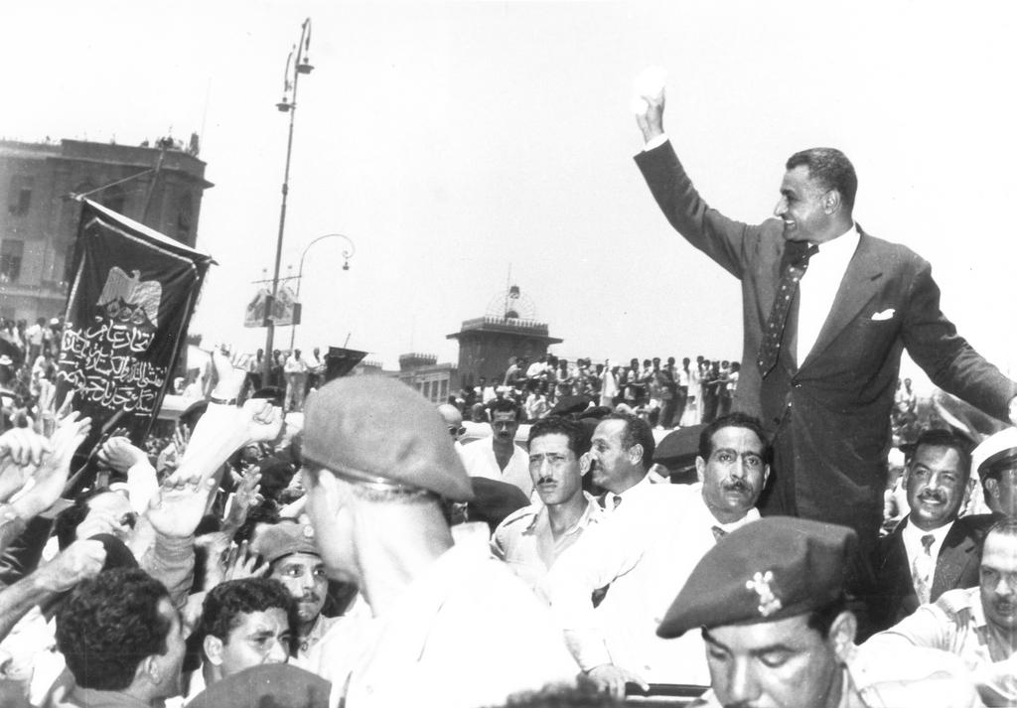

Nasser shortly after coming to power Anthony Eden: Primeminister in the Suez Crisis
In 1957 the Soviet Union launched the world’s first satellite. This caused a wave of hysteria that America had become lazy and was falling behind the Soviet Union scientifically. It raised the spectre of a Soviet missile that was capable of hitting anywhere in America, this criticism intensified after the American vanguard rocket exploded on its launching pad.
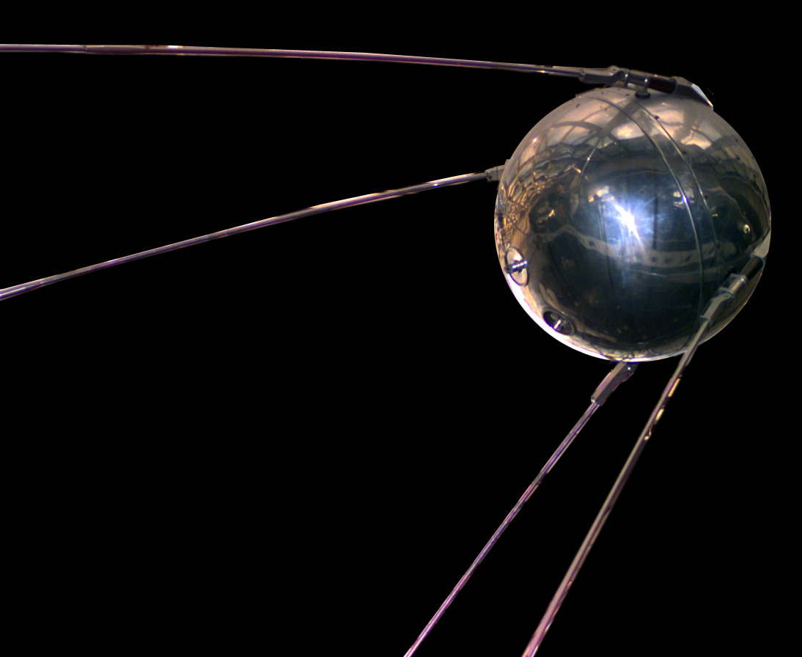

Sputnik

Repeated military build up on Quemoy and Matsu by Chiang, saw Mao resume the bombardment in September 1958 in an attempt to split the western alliance. This time the USA was not so quick to threaten Nuclear War. The Soviets had caught up and its allies were extremely nervous (the British PM – Harold Macmillan was in tears). In response the US cut a deal with China. If the islands were demilitarised, then the Chinese would recognise them to be Taiwans. In the end they were not completely demilitarised and the Chinese restricted their shelling to every second day – which continued into the 1970’s. It was enough however to prevent the threat of Nuclear war.
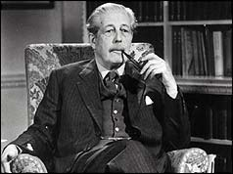
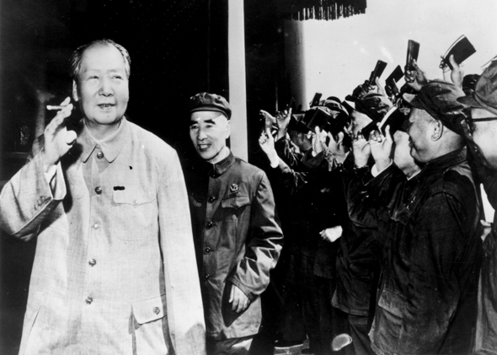

Chairman Mao in the 1950’s Harold Macmiilian

The back down with China encouraged Khrushchev to try and end the abnormal situation in Berlin. Between 1949-1958, US funds had turned West Berlin into an advertisement for Capitalism. It was an advertisement that worked, over a million East Germans had left the workers paradise and Khrushchev was under pressure from Ulbricht to do something about it. The success of the Berlin was also its weakness as it now meant that it could not be supplied from the air. At a Soviet-Polish friendship rally in November 1958, Khrushchev gave the west a six month ultimatum to leave Berlin. The US did not want war, but neither would it negotiate under an ultimatum. Instead it got the panicky Macmillan to organise a foreign ministers conference in order to try and engineer some ‘progress’. This allowed the deadline to pass and Eisenhower rewarded Khrushchev by inviting him to America, where he treated him as an equal at Camp David.
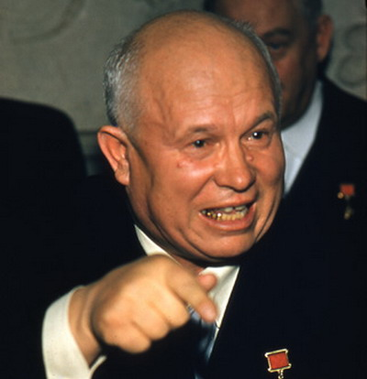
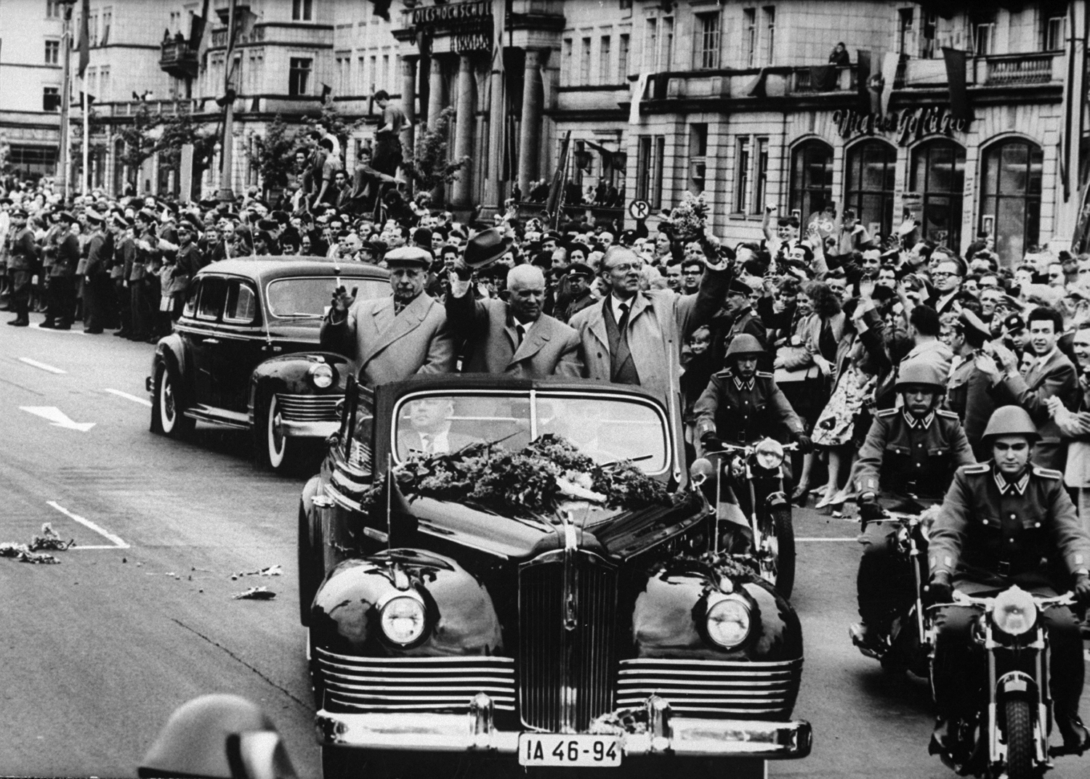

Khrushchev and Ulbricht in Berlin Nikia Khrushchev

The USA had been flying high altitude flights over the Soviet Union and photographing vast swathes of territory in specially built U-2 planes. Neither side admitted their existence, but in May 1960, the Soviet Union finally managed to shoot one down. Eisenhower lied and said it was a weather balloon, thinking the pilot would have committed suicide as instructed if he had survived. Khrushchev then brought out the pilot Gary Powers who had ‘converted’ to Communism, he then deliberately sabotaged the Paris conference on nuclear disarmament a few weeks later.
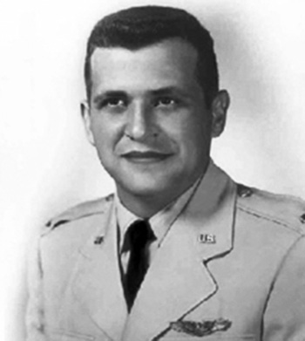

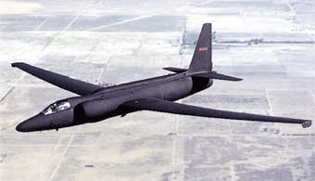

Gary Powers An American U2 Spy plane

Questions.

How has the US broken international law in Iran and Guatemala?

What methods have the US used to end conflicts in Asia?

Why was the Suez Crisis a disaster for the UK and destabilising to the Middle East?

How do both China and the USSR increase their prestige between 1958-1960?

